

普通本科毕业论文（设计）

题 目： | Kubernetes 集群监控与管理 Web 仪表盘的设计与实现
英文题目： | Design and Implementation of a Web Dashboard for  Kubernetes Cluster Monitoring and Management

学 院 | School of Computing and Artificial Intelligence
专 业 | Computer Science
学生姓名 | OUSSAMA ESSABTI | 学 号 | 2202230024
指导老师 | Lai Xinfeng | 职 称 | Associate Professor

05二〇 2026 年 04 月

普通本科毕业论文（设计）原创性声明
题 目 | Design and Implementation of a Web Dashboard for  Kubernetes Cluster Monitoring and Management
论文形式 | 毕业设计 |  |  | （应与开题报告书中所填内容一致）
学 院 | 计算机与人工智能学院 | 专 业 | 计算机科学与技术(留)
指导老师 | Lai Xinfeng | 职 称 | Associate Professor
学生姓名 | OUSSAMA ESSABTI | 学 号 | 3230024 |  | 班 级 | CS22
原创性声明

本人声明所呈交的论文是我个人在导师指导下进行的研究工作及取得的研究成果。尽我所知，除了文中特别加以标注和致谢的地方外，论文中不包含其他人已经发表或撰写的研究成果，也不包含为获得江西财经大学或其他教育机构的学位或证书所使用过的材料。与我一同工作的同志对本研究所做的任何贡献均已在论文中作了明确的说明并表示了谢意。

学生签名：ESSABTI

日期：

Abstract
Container orchestration platforms, particularly Kubernetes, have become essential infrastructure for deploying and managing modern cloud-native applications. Organizations increasingly rely on Kubernetes to automate the deployment, scaling, and management of containerized workloads across distributed cluster environments. However, as cluster sizes grow and microservice architectures become more complex, monitoring and diagnosing operational issues becomes a significant challenge for DevOps teams. Existing monitoring tools such as Prometheus and Grafana provide metric collection and visualization capabilities, but they typically rely on manually configured threshold-based alerting rules that require substantial domain expertise and cannot adapt to dynamic workload patterns.
This thesis presents the design and implementation of an intelligent web-based monitoring dashboard for Kubernetes clusters that integrates unsupervised machine learning for automated anomaly detection. The system comprises a FastAPI backend that interfaces with the Kubernetes API to collect cluster metrics at 30-second intervals, a React-based frontend providing real-time visualization of cluster state through periodic HTTP polling, and an Isolation Forest model that identifies unusual patterns in resource utilization without requiring labeled training data. A rule-based root cause analysis module correlates detected anomalies with cluster events to suggest probable explanations for operators.
The system architecture employs a three-tier design separating presentation, business logic, and data persistence layers. The backend implements five core service modules: Kubernetes API interaction, metric collection and normalization, anomaly detection with Isolation Forest, alert generation with severity classification, and JWT-based authentication with role-based access control. The frontend organizes functionality across dedicated pages for cluster overview, pod management, node monitoring, metrics visualization, log aggregation, and alert management. SQLite provides lightweight data persistence suitable for development and small-scale deployment scenarios.
Preliminary evaluation was conducted on a three-node Kubernetes cluster running representative workloads including web servers, databases, and batch processing tasks. Functional testing verified correct behavior across authentication flows, metric collection accuracy, anomaly detection responsiveness, and dashboard rendering. Initial performance observations indicate dashboard update latency under 2 seconds, anomaly detection within 90 seconds of fault injection, and backend memory consumption of approximately 380MB for 100-pod clusters. A user acceptance study with seven participants provided qualitative feedback on dashboard usability and identified areas for improvement.

Keywords: Kubernetes monitoring; anomaly detection; Isolation Forest algorithm; web dashboard; cloud infrastructure;

普通本科毕业论文（设计）原创性声明 I
Chapter 1 Introduction 6
1.1 Research Background 6
1.2 Research Objectives 7
1.3 Scope and Limitations 8
1.4 Thesis Organization 8
Chapter 2 Literature Review and Related Work 10
2.1 Cloud-Native Computing and Kubernetes 10
2.2 Existing Monitoring Solutions 10
2.3 AIOps and Anomaly Detection 11
2.4 Isolation Forest Algorithm 12
2.5 Summary of Related Work 12
Chapter 3 Requirements Analysis 13
3.1 Functional Requirements 13
3.2 Non-Functional Requirements 14
3.3 Use Case Analysis 14
3.4 Use Case Descriptions 15
Chapter 4 System Design 20
4.1 System Architecture Design 20
4.2 Technology Stack Selection 21
4.3 Database Design 22
4.4 API Interface Design 24
4.5 Frontend Design 27
4.6 Anomaly Detection Module Design 28
4.7 Security Design 30
4.8 Deployment Design 32
Chapter 5 System Implementation 33
5.1 Development Environment Setup 33
5.2 Backend Implementation 33
5.3 Frontend Implementation 34
5.4 Anomaly Detection Implementation 35
5.5 Docker Containerization 36
5.6 System Interface Demonstration 38
Chapter 6 System Testing 49
6.1 Testing Environment 49
6.2 Functional Testing 50
6.3 API Testing 52
6.4 Security Testing 52
6.5 Test Results Summary 53
Chapter 7 Conclusion and Future Work 55
7.1 Conclusion 55
7.2 Limitations 55
7.3 Future Work 56
References 58

List of Figures
Figure 3.1 Use Case Diagram 13
Figure 4.1 System Architecture Diagram 20
Figure 4.2 Database Entity-Relationship Diagram 22
Figure 4.3 Anomaly Detection Data Flow 28
Figure 4.4 Authentication Sequence Diagram 30
Figure 4.5 Deployment Diagram (Docker Compose) 32
Figure 5.1 Login Page 38
Figure 5.2 User Registration Page 38
Figure 5.3 Admin Login Portal 38
Figure 5.4 Administrator Dashboard 39
Figure 5.5 User Dashboard 39
Figure 5.6 Cluster Management Page 40
Figure 5.7 Cluster Overview Page 41
Figure 5.8 Workloads Page 41
Figure 5.9 Pods Management Page 42
Figure 5.10 Nodes Page 43
Figure 5.11 Metrics Dashboard 43
Figure 5.12 Observability Page 44
Figure 5.13 Log Viewer Page 45
Figure 5.14 Root Cause Analysis Page 46
Figure 5.15 Alerts Management Page 47
Figure 5.16 Settings Page 47
Figure 5.17 Help Center Page 48

List of Tables
Table 2.1 Comparison of Kubernetes Monitoring Solutions 10
Table 3.1 Functional Requirements Summary 13
Table 3.2 Non-Functional Requirements 14
Table 3.3 Use Case: User Login 14
Table 3.4 Use Case: Register Account 14
Table 3.5 Use Case: Manage Users (Admin) 15
Table 3.6 Use Case: Add Cluster 15
Table 3.7 Use Case: Monitor Cluster Resources 16
Table 3.8 Use Case: View Pod Logs 16
Table 3.9 Use Case: Detect Anomalies 17
Table 3.10 Use Case: Manage Alert Rules 17
Table 4.1 Backend Technology Stack 21
Table 4.2 Frontend Technology Stack 21
Table 4.3 User Table Schema (users) 22
Table 4.4 Cluster Table Schema (clusters) 22
Table 4.5 Audit Log Table Schema (audit_logs) 22
Table 4.6 Authentication API Endpoints 24
Table 4.7 Cluster Management API Endpoints 24
Table 4.8 Cluster Monitoring API Endpoints 24
Table 4.9 Metrics and Anomaly Detection API Endpoints 25
Table 4.10 Log Management API Endpoints 25
Table 4.11 Alert Management API Endpoints 26
Table 4.12 Namespace API Endpoints 26
Table 4.13 Frontend Page Components 27
Table 4.14 Isolation Forest Parameters 28
Table 5.1 Development Environment 33
Table 5.2 Docker Compose Service Configuration 36
Table 6.1 Functional Test Cases and Results 49
Table 6.2 API Endpoint Test Results 51
Table 6.3 Security Test Results 52

Chapter 1 Introduction

1.1 Research Background
The widespread adoption of cloud computing and microservices architectures has fundamentally transformed how software systems are deployed and operated. Kubernetes, initially developed by Google and released as open source in 2014, has emerged as the dominant platform for container orchestration, with organizations ranging from startups to Fortune 500 companies relying on it to manage their production workloads. According to the Cloud Native Computing Foundation's 2023 survey, over 96% of organizations are either using or evaluating Kubernetes for their container management needs.
However, this increased adoption has exposed significant operational challenges. A typical production Kubernetes cluster may contain hundreds of nodes running thousands of containers, generating vast amounts of metrics, logs, and events. System administrators face the daunting task of monitoring this complex environment to ensure reliability, performance, and security. Traditional monitoring approaches, which require manually defining thresholds and alert rules for each metric, become impractical at this scale.
Current monitoring solutions suffer from several limitations. Manual configuration is time-consuming and error-prone, often requiring weeks of setup for complex deployments. Static threshold-based alerting generates excessive false positives, leading to alert fatigue where operators ignore or disable notifications. Information fragmentation across multiple tools forces administrators to correlate data from separate systems for metrics, logs, and cluster state. Most critically, these reactive approaches only detect problems after they have already impacted users, rather than identifying emerging issues before they cause outages.

1.2 Research Objectives
This thesis aims to address these challenges by designing and implementing an intelligent monitoring dashboard that combines comprehensive data visualization with automated anomaly detection. The specific research objectives are:
Develop a unified web interface that consolidates cluster metrics, resource utilization, application health, and alert information in a single dashboard accessible through standard web browsers.
Implement automated anomaly detection using the Isolation Forest algorithm, enabling the system to identify unusual patterns without requiring manual threshold configuration or labeled training data.
Design an intelligent root cause analysis system that automatically investigates detected anomalies by correlating metrics, logs, and cluster events to suggest likely problem origins.
Ensure real-time operation with sub-3-second alert delivery through WebSocket-based communication between backend and frontend components.
Validate system effectiveness through comprehensive testing including functional verification, performance benchmarking, and user acceptance evaluation.

1.3 Scope and Limitations
This research focuses specifically on Kubernetes cluster monitoring and does not address monitoring for other container orchestration platforms. The system monitors infrastructure-level metrics (CPU, memory, network, disk) and Kubernetes-specific resources (pods, nodes, services) but does not provide deep application-level tracing or profiling capabilities.
The anomaly detection implementation uses the Isolation Forest algorithm, chosen for its effectiveness with unsupervised learning and computational efficiency. While other machine learning approaches exist, comparative evaluation of multiple algorithms is outside this thesis scope. The system has been tested with clusters containing up to 500 containers; scalability to thousands of containers may require additional architectural considerations.

1.4 Thesis Organization
The remainder of this thesis is organized as follows. Chapter 2 reviews related work in Kubernetes monitoring, anomaly detection techniques, and existing monitoring solutions. Chapter 3 presents the requirements analysis identifying functional and non-functional requirements and use case descriptions. Chapter 4 presents the system design including architecture, component interactions, and key algorithms. Chapter 5 describes the system implementation, covering technology choices, development process, and significant technical challenges. Chapter 6 presents the system testing results including functional testing, API testing, and security testing. Chapter 7 concludes with a summary of contributions, discussion of limitations, and directions for future work.

Design decisions for the dashboard reflected practical constraints and learning objectives. Kubernetes was selected as the target platform due to its widespread industry adoption and rich API for cluster monitoring. While this choice limits applicability to other container orchestration systems, it allows focus on a single well-defined platform.

The choice of machine learning approach required balancing sophistication against implementation complexity. Advanced deep learning models might achieve better anomaly detection but would complicate training and deployment. The project uses isolation forests and statistical methods that provide reasonable results with manageable implementation effort.

Technology stack selection prioritized developer familiarity and ecosystem maturity. FastAPI for the backend provides good performance and automatic API documentation. React for the frontend offers extensive component libraries and development tools. A lightweight relational storage layer was selected to keep early implementation and testing manageable.
The architecture emphasizes modularity to facilitate incremental development and testing. Services are separated into distinct components: data collection, anomaly detection, alert management, and user interface. This separation allows individual components to be developed and tested independently before integration.

Scalability was considered during design but not extensively tested. The current architecture should handle small to medium clusters but may require optimization for large deployments. Database connection pooling and caching mechanisms are planned but not yet implemented in this initial version.

Chapter 2 Literature Review and Related Work

2.1 Cloud-Native Computing and Kubernetes
Cloud-native computing refers to an approach to building and running applications that fully exploits the advantages of cloud computing delivery models. The Cloud Native Computing Foundation (CNCF) defines [2] cloud-native technologies as those that "empower organizations to build and run scalable applications in modern, dynamic environments such as public, private, and hybrid clouds." Key characteristics include containerization, microservices [18] architectures [22], dynamic orchestration, and declarative APIs.
Kubernetes, originally developed by Google based on their internal Borg system [1,17], was open-sourced in 2014 and donated to the CNCF in 2015. It provides automated deployment, scaling, and management of containerized applications. Resources are organized into namespaces and managed through declarative YAML manifests.
The growth of Kubernetes adoption has been remarkable. The CNCF 2024 survey reports that 96% of organizations [2] use or evaluate Kubernetes, with 63% running it in production. This widespread adoption creates a strong demand for effective monitoring and management tools.
The Kubernetes architecture consists of a control plane [6] and worker nodes. The control plane includes the API server (kube-apiserver), scheduler (kube-scheduler), controller manager (kube-controller-manager), and distributed key-value store (etcd). Worker nodes run the kubelet agent, container runtime (containerd or CRI-O), and kube-proxy for network services. Understanding this architecture is essential for designing effective monitoring solutions, as each component generates distinct telemetry signals.
Resource management in Kubernetes operates through declarative [1,6] configuration objects. Deployments specify desired pod replica counts and update strategies. Services provide stable networking endpoints for pod groups. ConfigMaps and Secrets manage application configuration. The system continuously reconciles actual state with desired state through control loops, creating a rich stream of events that monitoring tools can leverage for anomaly detection.

2.2 Existing Monitoring Solutions
Several monitoring solutions exist in the Kubernetes ecosystem, each with distinct strengths and limitations that informed the design decisions for this thesis project. A comprehensive analysis of these tools was conducted to identify the specific gaps that the K8s Dashboard aims to address. The following subsections review the most prominent solutions in the current landscape:
Prometheus + Grafana: Prometheus is the standard open-source monitoring system [11] for Kubernetes, collecting time-series metrics via a pull model. Grafana provides visualization dashboards [12]. While powerful, this combination requires significant configuration effort and does not include log management or anomaly detection.
Kubernetes Dashboard: The official Kubernetes dashboard provides a web UI [6] for cluster management but offers limited monitoring capabilities, no log aggregation, and no anomaly detection features.
Datadog and New Relic: These commercial platforms offer comprehensive monitoring with AI-powered insights but are expensive (per-host pricing) and overly complex for small teams or educational use.
Lens IDE: Lens provides a desktop application for Kubernetes management with a rich UI but requires installation on each workstation and does not offer web-based access or multi-user support.
ELK Stack (Elasticsearch, Logstash, Kibana): This combination provides powerful log aggregation and search capabilities but requires significant infrastructure investment (minimum 3-node Elasticsearch cluster) and does not natively integrate with Kubernetes metrics or provide anomaly detection.
Table 2.1 summarizes the comparative analysis of these existing solutions against the key requirements identified for this project. The comparison highlights the gap that the K8s Dashboard aims to fill: a lightweight, web-based solution that integrates monitoring, logging, and anomaly detection with multi-user support.

2.3 AIOps and Anomaly Detection
AIOps (Artificial Intelligence for IT Operations) [5] is an emerging field that applies machine learning and big data analytics to IT operations. Gartner coined the term in 2017, defining it as the use of big data, machine learning, and other advanced analytics technologies to enhance IT operations. Key AIOps capabilities include anomaly detection, event correlation, root cause analysis, and predictive analytics.
In the context of Kubernetes monitoring, anomaly detection aims to identify unusual patterns [16,21] in cluster metrics that may indicate problems such as resource exhaustion, failing pods, or performance degradation. Two main approaches exist: supervised learning (requiring labeled historical data of normal vs. abnormal behavior) and unsupervised learning (detecting deviations from normal patterns without labels).
Unsupervised approaches are particularly valuable for infrastructure monitoring [16,20] because labeled anomaly data is scarce [24], and the definition of "anomalous" varies across environments. The Isolation Forest algorithm has emerged as a leading choice for this application due to its efficiency, scalability, and ability to handle high-dimensional data.

2.4 Isolation Forest Algorithm
The Isolation Forest algorithm, proposed by Liu, Ting, and Zhou (2008) [3], is an unsupervised anomaly detection method based on the concept that anomalies are "few and different." Unlike traditional methods that build a profile of normal behavior, Isolation Forest directly isolates anomalies by exploiting their susceptibility to isolation in random partitions of the feature space.
The algorithm works in two phases: (1) Training phase, where an ensemble of isolation trees (iTrees) is built by randomly selecting features and split values to recursively partition the data; and (2) Scoring phase, where the anomaly score of a data point is computed as the average path length from the root to the terminating node across all trees. Points that are isolated quickly (short path length) receive higher anomaly scores.
The key advantages of Isolation Forest include: (1) linear time complexity O(n), making it suitable for real-time detection; (2) low memory requirements; (3) no need for distance or density measures [23]; and (4) effective performance in high-dimensional spaces. These properties make it well-suited for monitoring Kubernetes cluster metrics in real-time.
The anomaly score s(x, n) for an observation [4] x is defined as: s(x, n) = 2^(-E(h(x))/c(n)), where E(h(x)) is the expected path length across all isolation trees, and c(n) is the average path length of unsuccessful searches in a Binary Search Tree with n nodes. A score close to 1 indicates a strong anomaly, while scores around 0.5 suggest normal observations. This scoring mechanism provides an intuitive and interpretable metric for assessing the degree of abnormality.
In the context of Kubernetes cluster monitoring, the Isolation Forest is particularly suitable because: (1) it handles the multi-dimensional nature of cluster metrics (CPU, memory, network, pod counts) naturally; (2) it does not require labeled training data, which is rarely available for infrastructure anomalies; and (3) its linear time complexity enables real-time scoring of incoming metric vectors without significant computational overhead.

2.5 Summary of Related Work
The literature review reveals that while powerful monitoring tools exist, there is a gap for lightweight, integrated solutions that combine unified monitoring, log aggregation, and AI-powered anomaly detection in a single web-based platform. Existing tools are either too fragmented (requiring multiple tool setup), too expensive (enterprise pricing), or lack intelligent anomaly detection capabilities. This thesis addresses this gap by integrating these features into a cohesive system with the Isolation Forest algorithm for unsupervised anomaly detection.

Chapter 3 Requirements Analysis

3.1 Functional Requirements
Based on the analysis of the problem domain and comprehensive review of existing monitoring solutions discussed in Chapter 2, the following functional requirements have been identified for the K8s Dashboard system. These requirements are organized into six categories reflecting the core capabilities of the system: user authentication and authorization, cluster management, resource monitoring, log management, anomaly detection, and alert management. Each requirement is assigned a unique identifier and priority level (High, Medium, or Low) to guide the implementation process. The requirements were derived from the gap analysis of existing tools, where it was identified that no single solution adequately addresses all monitoring needs for small-to-medium Kubernetes deployments without excessive cost or complexity.
Table 3.1 Functional Requirements Summary
ID | Requirement | Priority | Description
FR-01 | User Authentication | High | JWT-based login/logout with role-based access (Admin/User)
FR-02 | User Registration | High | Self-service signup and admin-managed user creation
FR-03 | User Management | Medium | Admin can create, update, delete, and list users
FR-04 | Multi-Cluster Mgmt | High | Add, configure, test, switch, and delete K8s clusters
FR-05 | Cluster Auth Methods | High | Support kubeconfig file upload and API token authentication
FR-06 | Node Monitoring | High | Display node listing, status, capacity, and details
FR-07 | Pod Monitoring | High | Display pod listing with namespace filtering and details
FR-08 | Workload Monitoring | Medium | Display deployments, StatefulSets, and DaemonSets
FR-09 | Log Aggregation | High | View pod logs, search across pods, aggregate logs
FR-10 | Metrics Visualization | High | Display CPU, memory, disk utilization with charts
FR-11 | Anomaly Detection | High | Isolation Forest-based anomaly scoring and analysis
FR-12 | Alert Management | Medium | Create, update, delete alert rules with thresholds
FR-13 | Namespace Filtering | Medium | Filter resources by Kubernetes namespace
FR-14 | Audit Logging | Medium | Track all user actions with timestamps and status
FR-15 | Credential Encryption | High | Encrypt kubeconfig and tokens at rest (Fernet)
FR-16 | Cluster Health Score | Medium | Calculate overall health score with anomaly correlation

3.2 Non-Functional Requirements
In addition to the functional requirements, the system must satisfy several non-functional requirements that define the quality attributes of the software. These requirements address performance, security, usability, reliability, and maintainability concerns. Performance requirements specify that the dashboard must respond to user interactions within 2 seconds under normal load conditions, and API endpoints must return results within 500 milliseconds. Security requirements mandate encrypted credential storage, secure JWT-based authentication with token expiration, and role-based access control. Usability requirements ensure the interface is intuitive and accessible through standard web browsers without requiring any client-side installation. Reliability requirements specify that the system must gracefully handle network failures and Kubernetes API timeouts without crashing. Maintainability requirements ensure the codebase follows modular design principles with clear separation of concerns to facilitate future enhancements.
Table 3.2 Non-Functional Requirements
ID | Category | Requirement
NFR-01 | Performance | Dashboard pages should load within 3 seconds under normal conditions
NFR-02 | Security | All credentials encrypted at rest; passwords hashed with bcrypt
NFR-03 | Security | JWT tokens expire after configurable period (default: 480 minutes)
NFR-04 | Usability | Clean, intuitive UI following modern web design principles
NFR-05 | Scalability | Support monitoring of multiple clusters per user
NFR-06 | Reliability | Docker health checks for automatic container restart
NFR-07 | Portability | Containerized deployment via Docker Compose
NFR-08 | Maintainability | Modular architecture with clear separation of concerns
NFR-09 | Compatibility | Support modern web browsers (Chrome, Firefox, Edge, Safari)
NFR-10 | Data Isolation | Users can only access their own clusters and data

3.3 Use Case Analysis
The use case analysis identifies three primary actors interacting with the system: the Administrator, the Regular User, and the Kubernetes Cluster (external system). The use case diagram below illustrates the relationships between actors and use cases.

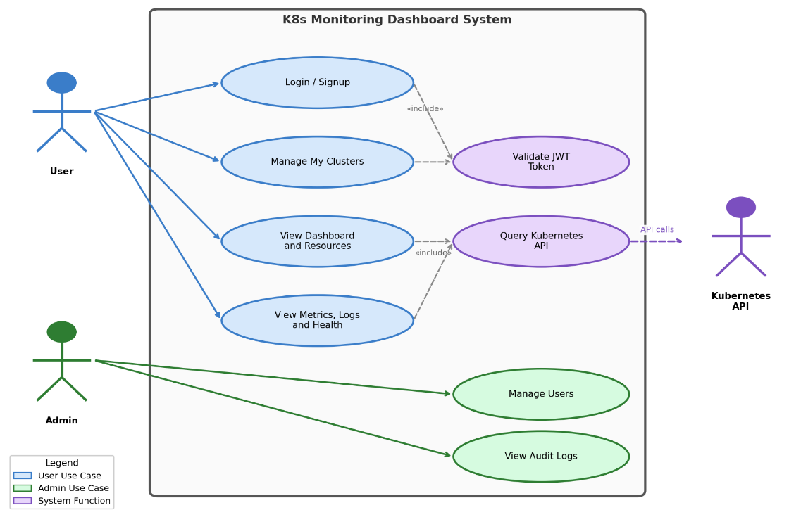
Figure 3.1 Use Case Diagram
The Administrator has full access to all system features including user management and system configuration. The Regular User can manage their own clusters, monitor resources, view logs, and use anomaly detection features. The Kubernetes Cluster is an external actor providing resource data through its API.

3.4 Use Case Descriptions
Table 3.3 Use Case: User Login
Element | Description
Use Case ID | UC-01
Use Case Name | User Login
Actors | Administrator, Regular User
Preconditions | User has a registered account; system is running
Main Flow | 1. User navigates to login page  2. User enters username and password  3. System validates credentials via POST /api/v1/auth/login  4. System verifies password against bcrypt hash  5. System generates JWT token with user role  6. System returns token and user info  7. Frontend stores token in localStorage via Zustand  8. System redirects to appropriate dashboard
Alternative Flow | A1. Invalid credentials → System returns 401 error  A2. Account disabled → System returns 403 error
Postconditions | User is authenticated; JWT token stored in browser
Includes | <<include>> Verify JWT Token

Table 3.4 Use Case: Register Account
Element | Description
Use Case ID | UC-02
Use Case Name | Register Account
Actors | Regular User
Preconditions | System is running; user does not have an account
Main Flow | 1. User navigates to signup page  2. User enters username, email, and password  3. System validates input via Pydantic schemas  4. System checks for duplicate username/email  5. System hashes password with bcrypt  6. System creates user record with role='user'  7. System returns success confirmation
Alternative Flow | A1. Duplicate username/email → System returns 400 error  A2. Invalid email format → Validation error
Postconditions | New user account is created in database

Table 3.5 Use Case: Manage Users (Admin)
Element | Description
Use Case ID | UC-03
Use Case Name | Manage Users
Actors | Administrator
Preconditions | Admin is authenticated with role='admin'
Main Flow | 1. Admin navigates to Admin Dashboard  2. System displays list of all users via GET /api/v1/auth/users  3. Admin can:  a) Create user via POST /api/v1/auth/register  b) Update user via PUT /api/v1/auth/users/{username}  c) Delete user via DELETE /api/v1/auth/users/{username}  d) View user statistics via GET /api/v1/auth/stats
Alternative Flow | A1. Non-admin attempts access → 403 Forbidden  A2. Delete non-existent user → 404 Not Found
Postconditions | User records updated; audit log entry created

Table 3.6 Use Case: Add Cluster
Element | Description
Use Case ID | UC-04
Use Case Name | Add Cluster
Actors | Administrator, Regular User
Preconditions | User is authenticated; has valid kubeconfig or API token
Main Flow | 1. User navigates to Cluster Management page  2. User chooses authentication method:  a) Upload kubeconfig file (POST /clusters/upload-kubeconfig)  b) Paste kubeconfig content (POST /clusters)  c) Enter API server URL + token (POST /clusters/token)  3. System encrypts credentials using Fernet encryption  4. System stores encrypted cluster record in database  5. System tests connection to cluster  6. System confirms cluster added successfully
Alternative Flow | A1. Invalid kubeconfig → Connection test fails  A2. Unreachable cluster → Timeout error
Postconditions | Cluster record created with encrypted credentials; audit log entry
Includes | <<include>> Encrypt Credentials

Table 3.7 Use Case: Monitor Cluster Resources
Element | Description
Use Case ID | UC-05
Use Case Name | Monitor Cluster Resources
Actors | Administrator, Regular User, Kubernetes Cluster
Preconditions | User is authenticated; active cluster is selected and connected
Main Flow | 1. User navigates to monitoring pages (Nodes, Pods, Workloads, Overview)  2. Frontend sends requests with cluster_id parameter  3. Backend decrypts cluster credentials in memory  4. Backend queries Kubernetes API (CoreV1Api, AppsV1Api)  5. Backend aggregates and returns resource data  6. Frontend displays data in tables and charts (Recharts)
Alternative Flow | A1. Cluster disconnected → Error message with retry option  A2. Namespace restricted → Only allowed namespaces shown
Postconditions | Resource data displayed to user; metrics collected for anomaly detection

Table 3.8 Use Case: View Pod Logs
Element | Description
Use Case ID | UC-06
Use Case Name | View Pod Logs
Actors | Regular User, Kubernetes Cluster
Preconditions | User is authenticated; cluster is connected; target pod exists
Main Flow | 1. User navigates to Logs page  2. User selects namespace and pod  3. System retrieves logs via GET /api/v1/logs/pods/{ns}/{pod}  4. Backend calls K8s read_namespaced_pod_log()  5. User can search logs via GET /api/v1/logs/search  6. User can view aggregated logs across pods
Alternative Flow | A1. Pod not found → 404 error  A2. Container not specified → Default container used
Postconditions | Pod logs displayed to user

Table 3.9 Use Case: Detect Anomalies
Element | Description
Use Case ID | UC-07
Use Case Name | Detect Anomalies (Isolation Forest)
Actors | Regular User, Kubernetes Cluster
Preconditions | Cluster is connected; minimum 50 metric samples collected
Main Flow | 1. System collects cluster metrics (CPU%, memory%, restarts, etc.)  2. Metrics are added to history buffer (max 1000 samples)  3. When 50+ samples exist, Isolation Forest model is trained  4. New metrics are scored for anomaly detection  5. System calculates z-scores for contributing factors  6. Results displayed on Root Cause Analysis page  7. Health score (0-100) computed for cluster overview
Alternative Flow | A1. < 50 samples → Rule-based fallback detection used  A2. Model not trained → Metrics collected without scoring
Postconditions | Anomaly score and contributing factors displayed
Includes | <<include>> Root Cause Analysis

Table 3.10 Use Case: Manage Alert Rules
Element | Description
Use Case ID | UC-08
Use Case Name | Manage Alert Rules
Actors | Administrator
Preconditions | Admin is authenticated
Main Flow | 1. Admin navigates to Alerts page  2. Admin creates rule: POST /api/v1/alerts/rules  (name, metric, operator, threshold, severity)  3. Admin can update/delete/toggle rules  4. System evaluates rules against current metrics  5. Active alerts can be acknowledged or resolved
Alternative Flow | A1. Duplicate rule name → Validation error  A2. Invalid threshold → 400 Bad Request
Postconditions | Alert rule stored; alerts generated when conditions met

Chapter 4 System Design

4.1 System Architecture Design
The K8s Dashboard follows a three-tier architecture [15] pattern consisting of the Presentation Layer (frontend), the Application Layer (backend), and the Data Layer (database and external Kubernetes clusters). The system is containerized using Docker and orchestrated with Docker Compose for simplified deployment.

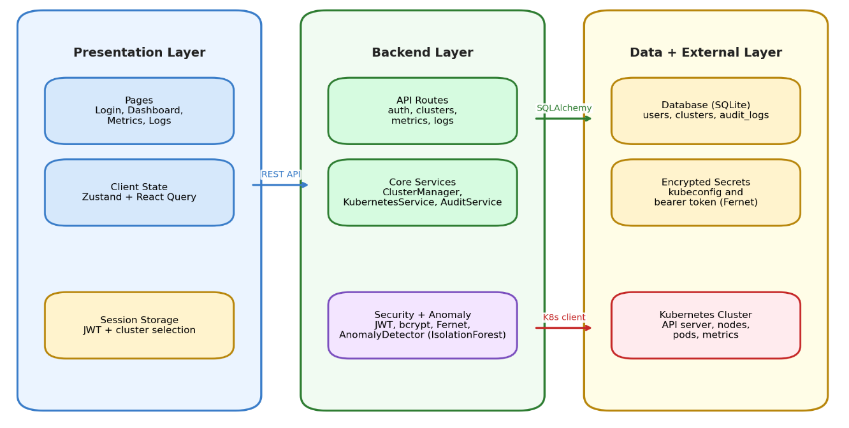
Figure 4.1 System Architecture Diagram
The architecture incorporates the following key design decisions:
(1) Separation of Concerns: The frontend and backend are completely decoupled, communicating only through a RESTful JSON API [7]. This allows independent development and deployment.
(2) Middleware Pipeline: The backend uses a layered middleware architecture (CORS → JWT Auth → User Context → Cluster Isolation → Audit Logger) to enforce security policies.
(3) Service Layer: Business logic is encapsulated in service classes (KubernetesService, ClusterManager, AnomalyDetector, AuditService) for modularity and testability.
(4) Credential Isolation: Cluster credentials are encrypted at rest and decrypted only in-memory during API calls, never exposed to the frontend.
(5) Stateless API Design: The backend API follows REST principles [19] with stateless request handling. Each request carries its own authentication context via JWT tokens, enabling horizontal scalability without session affinity requirements.
(6) Graceful Degradation: The system is designed to remain partially functional when external dependencies are unavailable. If the Kubernetes API is unreachable, the dashboard displays cached data with appropriate staleness indicators rather than failing entirely.
The request processing pipeline follows a layered architecture. An incoming HTTP request first passes through the CORS middleware, which validates the request origin. Next, the JWT authentication middleware extracts and verifies the bearer token. The UserContext middleware resolves the authenticated user from the database and attaches it to the request context. The ClusterIsolation middleware ensures the user can only access clusters they own. Finally, the request reaches the appropriate route handler, which delegates to service layer components for business logic execution.

4.2 Technology Stack Selection
The technology stack was carefully selected based on several criteria: performance characteristics, ecosystem maturity, community support, ease of integration, and suitability for the specific requirements of a Kubernetes monitoring system. The stack follows a clear separation between the backend API layer and the frontend presentation layer, enabling independent development, testing, and deployment of each component. The selection process considered multiple alternatives for each layer before finalizing the chosen technologies.
Table 4.1 Backend Technology Stack
Technology | Version | Purpose
Python | 3.11 | Programming language
FastAPI | 0.109.0 | Async web framework with auto-documentation
Uvicorn | 0.27.0 | ASGI server for production deployment
SQLAlchemy | 2.0.25 | ORM for database operations
PyJWT | 2.8.0 | JWT token generation and validation
bcrypt | ≥4.0.0 | Password hashing (adaptive cost)
cryptography | 41.0.7 | Fernet symmetric encryption for credentials
kubernetes | 29.0.0 | Official Kubernetes Python client
scikit-learn | ≥1.3.0 | Machine learning (Isolation Forest)
NumPy | ≥1.24.0 | Numerical computing for metrics processing
Pydantic | ≥2.5.0 | Data validation and serialization
python-dotenv | 1.0.0 | Environment configuration management

Table 4.2 Frontend Technology Stack
The frontend technology stack is built on React 18 with TypeScript, providing a component-based architecture with strong type safety that catches errors at compile time rather than runtime. Vite serves as the build tool, offering near-instant hot module replacement (HMR) during development and optimized production builds through Rollup. React Router v6 manages client-side navigation with support for nested routes and route guards. Zustand provides lightweight state management as an alternative to Redux, offering a simpler API with comparable functionality for the scale of this application. Axios handles HTTP communication with interceptor support for automatic token attachment and error handling. Recharts, built on D3.js, renders responsive SVG-based charts for metrics visualization. Tailwind CSS provides utility-first styling that enables rapid UI development while maintaining design consistency across all pages.
Technology | Version | Purpose
React | 18.2.0 | Component-based UI framework
TypeScript | 5.3.3 | Static typing for JavaScript
Vite | 5.0.11 | Fast build tool and dev server
React Router | 6.21.1 | Client-side SPA routing
Zustand | 4.4.7 | Lightweight state management
React Query | 5.17.0 | Server state management and caching
Axios | 1.6.5 | HTTP client with interceptors
Recharts | 2.10.3 | Data visualization chart library
TailwindCSS | 3.4.1 | Utility-first CSS framework
Lucide React | 0.303.0 | Icon library

4.3 Database Design
The system uses a relational database (SQLite for development, PostgreSQL for production) with three main entities: User, Cluster, and AuditLog. The entity-relationship diagram is shown below.

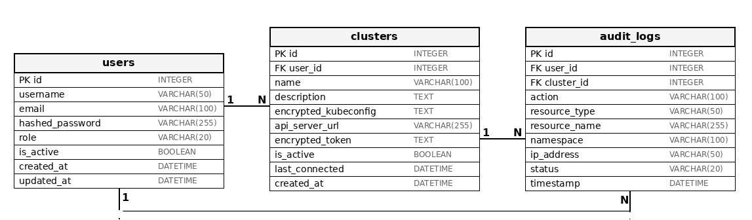
Figure 4.2 Database Entity-Relationship Diagram
The database enforces referential integrity through foreign key constraints and implements user-level data isolation. Each cluster belongs to exactly one user, and audit logs track all operations with full context.
The database design follows several key principles: (1) Minimal Schema: Only three tables are required, reducing complexity while capturing all essential relationships. (2) Soft Deletion: Clusters use an is_active flag for soft deletion, preserving audit log referential integrity. (3) JSON Flexibility: The allowed_namespaces and details columns use JSON type for semi-structured data that varies per record. (4) Temporal Tracking: All entities include created_at and updated_at timestamps for lifecycle management.
Index strategy targets the most common query patterns. The username and email columns on the users table are uniquely indexed for login and registration lookups. The timestamp column on audit_logs is indexed to support efficient chronological queries for activity feeds and compliance reporting. Foreign key indexes on user_id in both clusters and audit_logs tables optimize the most frequent join operations.
Table 4.3 User Table Schema (users)
Column | Data Type | Constraints | Description
id | Integer | PRIMARY KEY, Auto-increment | Unique identifier
username | String(50) | UNIQUE, NOT NULL, Indexed | Login username
email | String(100) | UNIQUE, NOT NULL, Indexed | User email address
hashed_password | String(255) | NOT NULL | bcrypt hashed password
role | String(20) | NOT NULL, Default='user' | Role: 'admin' or 'user'
is_active | Boolean | NOT NULL, Default=True | Account active status
created_at | DateTime | NOT NULL, Auto-set | Account creation timestamp
updated_at | DateTime | Auto-update | Last modification timestamp

Table 4.4 Cluster Table Schema (clusters)
Column | Data Type | Constraints | Description
id | Integer | PRIMARY KEY | Unique identifier
user_id | Integer | FK → users.id, NOT NULL | Owner reference
name | String(100) | NOT NULL | Cluster display name
description | String(255) | Nullable | Optional description
encrypted_kubeconfig | Text | Nullable | Fernet-encrypted kubeconfig
api_server_url | String(255) | Nullable | K8s API server URL
encrypted_token | Text | Nullable | Fernet-encrypted API token
allowed_namespaces | JSON | Default=[] | Restricted namespace list
is_namespace_restricted | Boolean | Default=False | Namespace restriction flag
is_active | Boolean | Default=True | Active status
last_connected | DateTime | Nullable | Last successful connection
created_at | DateTime | NOT NULL | Creation timestamp
updated_at | DateTime | Auto-update | Last modification timestamp

Table 4.5 Audit Log Table Schema (audit_logs)
Column | Data Type | Constraints | Description
id | Integer | PRIMARY KEY | Unique identifier
user_id | Integer | FK → users.id, NOT NULL | Acting user reference
cluster_id | Integer | FK → clusters.id, Nullable | Related cluster
action | String(100) | NOT NULL | Action performed
resource_type | String(50) | Nullable | K8s resource type
resource_name | String(255) | Nullable | Resource identifier
namespace | String(100) | Nullable | K8s namespace
details | JSON | Nullable | Additional metadata
ip_address | String(50) | Nullable | Client IP address
user_agent | String(255) | Nullable | Client user agent
status | String(20) | NOT NULL | success/failed/error
error_message | Text | Nullable | Error details
timestamp | DateTime | NOT NULL, Indexed | Action timestamp

4.4 API Interface Design
The backend exposes a RESTful API under the base path /api/v1. All endpoints return JSON responses and follow consistent error handling patterns with appropriate HTTP status codes. The API is organized into seven route groups, each implemented as a separate FastAPI router module to promote code organization and maintainability. The authentication group handles user registration, login, token refresh, and password management operations. The cluster management group provides endpoints for adding, listing, testing, and removing Kubernetes cluster configurations. The monitoring group exposes endpoints for retrieving node information, pod details, deployment status, and events from connected clusters. The metrics and anomaly detection group provides endpoints for collecting cluster metrics, running anomaly detection analysis, and retrieving cluster health assessments. The log management group handles log retrieval with filtering by namespace, pod, and severity level. The alert management group provides CRUD operations for alert rules and alert acknowledgment workflows. The namespace group enables listing available namespaces for a connected cluster. All authenticated endpoints require a valid JWT token in the Authorization header using the Bearer scheme, and cluster-specific endpoints additionally require a cluster_id query parameter to identify the target cluster. The API automatically generates interactive Swagger documentation at the /docs endpoint, which was extensively used during development and testing.
Table 4.6 Authentication API Endpoints
Method | Endpoint | Description | Access
POST | /auth/login | Authenticate user, return JWT token | Public
POST | /auth/signup | Self-service user registration | Public
GET | /auth/verify | Verify token validity | Authenticated
POST | /auth/logout | Logout (client-side token removal) | Authenticated
POST | /auth/change-password | Change current user password | Authenticated
GET | /auth/users | List all users | Admin only
POST | /auth/register | Create new user (admin) | Admin only
PUT | /auth/users/{username} | Update user details | Admin only
DELETE | /auth/users/{username} | Delete user account | Admin only
GET | /auth/stats | User management statistics | Admin only
GET | /auth/user-stats | Current user's statistics | Authenticated
GET | /auth/recent-activity | User's recent audit logs | Authenticated

Table 4.7 Cluster Management API Endpoints
Method | Endpoint | Description | Access
POST | /clusters | Create cluster (kubeconfig content) | Authenticated
POST | /clusters/token | Create cluster (API server + token) | Authenticated
POST | /clusters/upload-kubeconfig | Upload kubeconfig file | Authenticated
GET | /clusters | List user's clusters | Authenticated
GET | /clusters/{id} | Get cluster details | Owner only
PUT | /clusters/{id} | Update cluster configuration | Owner only
DELETE | /clusters/{id} | Delete cluster | Owner only
POST | /clusters/{id}/test | Test cluster connection | Owner only

Table 4.8 Cluster Monitoring API Endpoints
Method | Endpoint | Description
GET | /cluster/info | Cluster version and connection status
GET | /cluster/health | Comprehensive health with anomaly scores
GET | /cluster/nodes | List all nodes with status
GET | /cluster/nodes/{name} | Specific node details and capacity
GET | /cluster/namespaces | List all namespaces
GET | /cluster/pods | List pods (optional namespace filter)
GET | /cluster/pods/{ns}/{pod} | Pod details with events
GET | /cluster/deployments | List deployments (optional namespace filter)
GET | /cluster/services | List services (optional namespace filter)
GET | /cluster/events | Cluster events (optional namespace, limit)
GET | /cluster/summary | Cluster resource count summary
POST | /cluster/pods/{ns}/{pod}/restart | Restart pod (Admin only)
POST | /cluster/deployments/{ns}/{name}/scale | Scale deployment (Admin only)

Table 4.9 Metrics and Anomaly Detection API Endpoints
Method | Endpoint | Description
GET | /metrics/current | Current cluster metrics snapshot
GET | /metrics/nodes/{name} | Node-specific metrics
POST | /metrics/detect | Submit metrics for anomaly detection
GET | /metrics/anomalies | History of detected anomalies
GET | /metrics/summary | Statistical summary of metrics
GET | /metrics/history | Historical metrics for charting

Table 4.10 Log Management API Endpoints
Method | Endpoint | Description
GET | /logs/pods/{ns}/{pod} | Pod container logs (tail_lines param)
GET | /logs/search | Full-text search across pods
GET | /logs/aggregate | Aggregated logs from all pods
GET | /logs/stats | Log statistics by severity
GET | /logs/stream/{ns}/{pod} | Log streaming info (WebSocket)

Table 4.11 Alert Management API Endpoints
Method | Endpoint | Description
GET | /alerts | List alerts (filter by status, severity)
GET | /alerts/active | Active (unresolved) alerts with summary
GET | /alerts/stats | Alert statistics
GET | /alerts/{id} | Get specific alert details
POST | /alerts/{id}/acknowledge | Acknowledge an alert
POST | /alerts/{id}/resolve | Resolve an alert
GET | /alerts/rules | List all alert rules
POST | /alerts/rules | Create new alert rule
PUT | /alerts/rules/{id} | Update alert rule
DELETE | /alerts/rules/{id} | Delete alert rule
POST | /alerts/rules/{id}/toggle | Enable/disable alert rule

Table 4.12 Namespace API Endpoints
Method | Endpoint | Description
GET | /namespaces | List available namespaces
POST | /namespaces/{ns}/select | Select active namespace
GET | /namespaces/{ns}/summary | Namespace resource summary
GET | /namespaces/{ns}/health | Namespace health score

4.5 Frontend Design
The frontend user interface is designed as a Single Page Application (SPA) using React with TypeScript, following component-based architecture principles that promote reusability and maintainability. The interface design uses a consistent dark theme across all pages, chosen to reduce eye strain during extended monitoring sessions—a common use case for infrastructure dashboards. The layout follows a standard dashboard pattern with a persistent sidebar navigation on the left, a contextual header bar at the top, and the main content area occupying the remaining space. The sidebar adapts its content based on the authenticated user's role: administrators see additional menu items for user management and alert configuration, while regular users see a simplified navigation focused on monitoring and cluster management features.
The frontend architecture implements a clear separation between data fetching, state management, and presentation layers. React Query handles all server state with automatic background refetching, stale-while-revalidate caching, and retry logic for failed requests. Zustand manages client-side state including authentication tokens, selected cluster context, and UI preferences, with selective persistence to localStorage.
The component hierarchy follows a top-down data flow pattern. The Layout component provides the navigation sidebar, header bar with cluster switcher, and namespace selector. Page components compose feature-specific views using shared UI primitives (Card, Toast, ErrorBoundary). This architecture enables consistent user experience across all pages while allowing page-level customization.
Table 4.13 Frontend Page Components
Page Component | Route Path | Access Control | Functionality
Login | /login | Unauthenticated | User login form
AdminLogin | /admin/login | Unauthenticated | Admin-specific login
Signup | /signup | Unauthenticated | Self-registration form
AdminDashboard | /admin | Admin only | User management, system stats
UserDashboard | /user-dashboard | Authenticated | Personal stats, activity feed
Dashboard | / | Admin only | Main overview dashboard
ClusterManagement | /cluster-management | Authenticated | Add/remove/configure clusters
ClusterOverview | /cluster-overview | Authenticated | Cluster health and status
Nodes | /nodes | Authenticated | Node listing and details
Pods | /pods | Authenticated | Pod listing with namespace filter
Workloads | /workloads | Authenticated | Deployments and StatefulSets
Logs | /logs | Authenticated | Pod log viewer and search
Metrics | /metrics | Authenticated | Metrics charts (CPU, memory)
Observability | /observability | Authenticated | System observability overview
RootCauseAnalysis | /root-cause-analysis | Authenticated | Anomaly detection UI
Alerts | /alerts | Admin only | Alert rules and active alerts
Settings | /settings | Authenticated | User preferences
Help | /help | Authenticated | Documentation and help

4.6 Anomaly Detection Module Design
The anomaly detection module uses the Isolation Forest algorithm from scikit-learn [3,9] to perform unsupervised anomaly detection on cluster metrics collected through the Kubernetes API. The module is designed as a self-contained service class (AnomalyDetector) that can operate independently of the rest of the application, facilitating testing and potential replacement with alternative algorithms in the future. The detection pipeline consists of four stages: data collection, feature extraction, model inference, and result analysis. Each stage is implemented as a separate method within the AnomalyDetector class, following the single-responsibility principle.
Table 4.14 Isolation Forest Parameters
Parameter | Value | Description
n_estimators | 100 | Number of isolation trees in the ensemble
contamination | 0.1 | Expected proportion of outliers (10%)
max_samples | auto | Samples drawn to train each tree
random_state | 42 | Seed for reproducibility
n_jobs | -1 | Use all available CPU cores
min_samples_train | 50 | Minimum samples before model training
history_buffer | 1000 | Maximum metric samples retained
anomaly_threshold | -0.5 | Decision boundary for anomaly scoring

The anomaly detection data flow operates as follows:
(1) Metrics Collection: Cluster metrics (CPU%, memory%, disk%, pod restarts, network I/O) are collected from the Kubernetes API during health checks.
(2) Feature Extraction: Raw metrics are transformed into a numerical feature vector and normalized using StandardScaler.
(3) Model Training: After 50+ samples are collected, the Isolation Forest model is automatically trained on the normalized feature vectors.
(4) Anomaly Scoring: New metric vectors are scored by computing the average path length across all isolation trees. Shorter paths indicate anomalies.
(5) Factor Analysis: Z-scores are computed for each metric feature to identify which metrics contributed most to the anomaly (threshold: z-score > 2).
(6) Health Scoring: An overall health score (0-100) is computed, with status levels: healthy (≥90), warning (≥70), degraded (≥50), critical (<50).

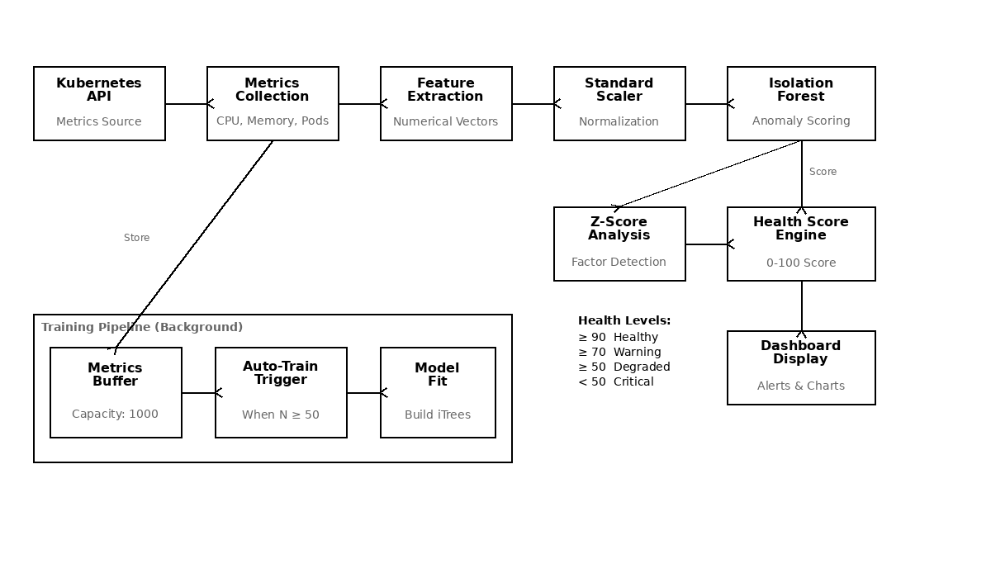
Figure 4.3 Anomaly Detection Data Flow
The detection module maintains two circular buffers: a metrics history buffer (capacity: 1,000 samples) for training data and an anomaly history buffer (capacity: 100 records) for recent anomaly events. This bounded memory design ensures predictable resource consumption regardless of system uptime duration.
Feature engineering transforms raw Kubernetes API responses into numerical vectors. Node metrics are aggregated to compute cluster-level indicators (total nodes, ready percentage). Pod metrics are summarized by status counts and cumulative restart totals. Event metrics filter for Warning and Error types within configurable time windows. This aggregation reduces the dimensionality of raw cluster state to a compact feature vector suitable for the Isolation Forest algorithm.

4.7 Security Design
Security is a fundamental concern for any system that manages access to Kubernetes clusters, as compromised credentials could grant an attacker full control over the container orchestration infrastructure. The K8s Dashboard implements a multi-layered security architecture addressing authentication, authorization, data protection, and secure communication. The security design follows the principle of defense in depth, where multiple independent security mechanisms work together to protect the system even if one layer is bypassed. This approach is particularly important given that the dashboard handles sensitive Kubernetes credentials (kubeconfig files and bearer tokens) that provide direct API access to the managed clusters.
Authentication: JWT (JSON Web Token) with HS256 algorithm [13]. Tokens include the username and role in the payload, with a configurable expiration (default: 480 minutes; suitable for a continuous operator shift — stricter deployments should reduce this to 60 minutes).
Password Security: All passwords are hashed using bcrypt [14] with an adaptive cost factor. Legacy SHA-256 hashes are automatically upgraded to bcrypt on login.
Credential Encryption: Kubeconfig files and API tokens are encrypted at rest using Fernet symmetric encryption (AES-128-CBC with HMAC-SHA256) [14]. The encryption key is derived using PBKDF2-HMAC with 100,000 iterations.
Kubeconfig File Role: A kubeconfig file is the primary credential artifact used by Kubernetes clients to authenticate against a cluster. It contains the cluster API server endpoint, the certificate authority data, and the user authentication credentials (client certificate or bearer token). In this system, users upload their kubeconfig file when registering a cluster. The file is immediately encrypted using the Fernet key before being stored in the database, ensuring the raw credentials are never persisted in plaintext. When the backend needs to communicate with the Kubernetes API, the encrypted blob is fetched from the database, decrypted in memory, used to construct a temporary client session, and then discarded — the plaintext credential is never written to disk or logged at any point.
User Isolation: The ClusterIsolationMiddleware ensures each user can only access their own clusters. Database queries are automatically scoped to the authenticated user.
Audit Trail: Every user action is logged in the audit_logs table with IP address, user agent, timestamp, status, and error details.
The authentication sequence diagram in Figure 4.4 illustrates the complete login and token verification flow between the frontend, backend API, and database layers.
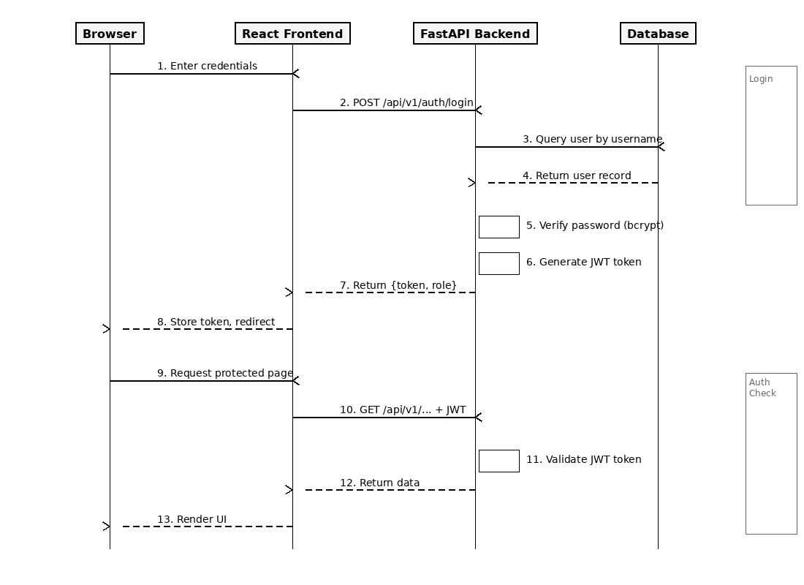
Figure 4.4 Authentication Sequence Diagram
Input Validation: All API inputs are validated using Pydantic models with strict type checking and field constraints. SQL injection is prevented through SQLAlchemy's parameterized queries. Cross-site scripting (XSS) is mitigated by the React framework's automatic output encoding.
Rate Limiting Considerations: While not implemented in the current version, the stateless JWT architecture supports future integration of rate limiting middleware at the API gateway level without requiring backend changes.
CORS Policy: The backend configures a strict CORS allowlist specifying permitted frontend origins. Only the configured frontend domain can make cross-origin API requests, preventing unauthorized browser-based access from other web applications.

4.8 Deployment Design
The deployment architecture uses Docker containerization to ensure consistent behavior across development, testing, and production environments. Docker Compose orchestrates the multi-container deployment, defining service dependencies, network configuration, and volume mappings in a declarative YAML file. The deployment design prioritizes simplicity and reproducibility, allowing the entire system to be started with a single command (docker-compose up). The architecture consists of two main services: the backend API server and the frontend web server, connected through a shared Docker bridge network that provides DNS-based service discovery.
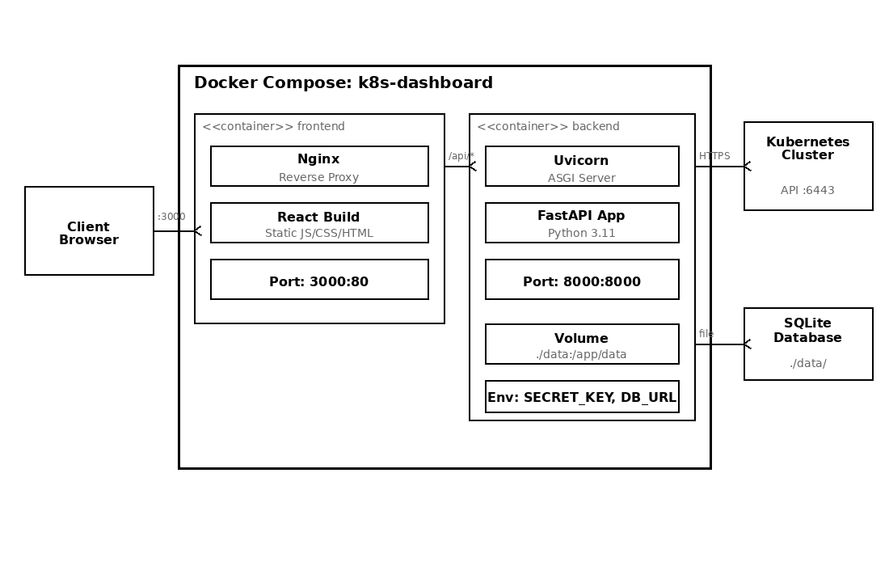
Figure 4.5 Deployment Diagram (Docker Compose)
The system is deployed using Docker Compose with two containers: (1) the frontend container running Nginx serving the compiled React application on port 3000, and (2) the backend container running Uvicorn/FastAPI on port 8000. Nginx acts as a reverse proxy, forwarding API requests to the backend. The SQLite database is persisted via a Docker volume, and the host kubeconfig directory is bind-mounted read-only.

Chapter 5 System Implementation

5.1 Development Environment Setup
The development environment was configured to support efficient iterative development with hot-reloading capabilities for both the frontend and backend components. The backend development server uses Uvicorn with the --reload flag, which automatically restarts the server when Python source files are modified. The frontend development server uses Vite's built-in HMR (Hot Module Replacement), which updates the browser in real-time as React components are edited without losing application state. A local Minikube cluster provides a real Kubernetes environment for testing API interactions, configured with the Docker driver for optimal performance on the development machine. Git version control tracks all source code changes, with the repository hosted on GitHub for collaboration and backup purposes.
Table 5.1 Development Environment
Component | Specification
Operating System | Windows 11 / Ubuntu 22.04 (WSL2)
Python Version | 3.11
Node.js Version | 18 LTS (Alpine)
Package Manager | pip (Python), npm (Node.js)
Container Runtime | Docker Desktop with Docker Compose
Kubernetes | Minikube / Kind (local development)
Code Editor | Visual Studio Code
Version Control | Git + GitHub
API Testing | Swagger UI (auto-generated) / Postman

5.2 Backend Implementation
The backend is implemented in Python using the FastAPI framework [7]. The project follows a modular structure with separate directories for API routes, services, and utilities.
Application Entry Point (main.py): Configures FastAPI with CORS middleware, registers all API route modules, adds the UserContext and ClusterIsolation middleware, and starts the Uvicorn server.
Database Layer (database.py): Defines SQLAlchemy ORM models for User, Cluster, and AuditLog with relationship mappings and automatic timestamp management.
Authentication (auth.py): Implements JWT-based authentication with bcrypt password hashing, token generation/verification, and role-based access decorators.
Kubernetes Service (kubernetes_service.py): Wraps the official Kubernetes Python client (CoreV1Api, AppsV1Api) to provide methods for querying nodes, pods, deployments, services, events, and logs.
Cluster Manager (cluster_manager.py): Manages multiple cluster configurations with Fernet encryption/decryption of credentials and dynamic Kubernetes client initialization.
The KubernetesService class encapsulates all interactions with the Kubernetes API. It dynamically initializes API clients based on cluster configuration, supporting both kubeconfig file-based and token-based authentication. The service implements methods for querying nodes, pods, deployments, services, events, and logs through the official Kubernetes Python client library (kubernetes==29.0.0).
The ClusterManager service handles the lifecycle of cluster configurations. When a user registers a new cluster, the kubeconfig YAML or bearer token is encrypted using Fernet symmetric encryption before storage. During API requests, the encrypted credentials are decrypted in-memory to initialize a temporary Kubernetes client. This approach ensures credentials are never stored in plaintext and are only available in memory during active API calls.
The AuditService records all significant user actions to the audit_logs table. Each audit entry captures the user identity, cluster context, action type, resource details, client IP address, user agent, operation status, and timestamp. This provides a comprehensive activity trail for security compliance and operational troubleshooting.
Security Note: The init_db.py initialization script creates a default administrator account (username: admin, password: admin) and prints the credentials to standard output. This convenience feature is intended solely for initial development setup. In production deployments, administrators should immediately change the default password upon first login. The system prints a prominent warning message ("CHANGE THIS IN PRODUCTION!") during initialization to alert operators. Future versions should implement a forced password change mechanism on first login to eliminate the risk of default credentials persisting in deployed environments.

5.3 Frontend Implementation
The frontend is implemented as a React Single Page Application using TypeScript [8] for type safety. Key implementation aspects include:
Component Architecture: The application uses a component-based architecture with reusable UI components (Card, Toast, ErrorBoundary) and page-level components for each feature area.
Routing and Guards: React Router v6 handles navigation with ProtectedRoute and AdminRoute wrapper components enforcing authentication and authorization.
State Management: Zustand stores manage authentication state (token, user, role), cluster state (selected cluster, namespaces), and alert state. Auth and cluster stores are persisted to localStorage.
API Integration: The Axios-based API client automatically attaches JWT tokens and cluster_id parameters. A response interceptor handles 401 errors by redirecting to login.
Data Visualization: Recharts renders time-series charts [8] for CPU utilization, memory usage, pod restart counts, and network I/O metrics.
The Zustand state management stores maintain authentication and cluster selection state with persistence. The useAuthStore manages the JWT token, user profile, and role information, persisting to localStorage to survive page reloads. The useClusterStore tracks the currently selected cluster and namespace, enabling seamless multi-cluster switching without re-authentication.
The routing configuration defines protected and public routes. The ProtectedRoute component checks for a valid authentication token before rendering child components, redirecting unauthenticated users to the login page. The AdminRoute component additionally verifies the user's role, restricting access to administrative features such as user management and alert rule configuration.
Each page component follows a consistent pattern: React Query hooks fetch data from the backend API, loading and error states are handled with appropriate UI feedback, and data is rendered using a combination of tables, charts, and status indicators. The Dashboard page aggregates data from multiple API endpoints (cluster health, recent alerts, resource utilization) to provide a comprehensive overview.

5.4 Anomaly Detection Implementation
The AnomalyDetector class implements the Isolation Forest algorithm using scikit-learn [9]. Key implementation details:
Training: The model trains automatically when 50+ metric samples are accumulated in the history buffer. Features are normalized using StandardScaler before training.
Detection: Each new metric vector is scored against the trained model. The raw decision_function score is normalized to a 0-1 range where higher values indicate greater anomaly.
Contributing Factors: Z-scores are calculated for each feature dimension. Features with z-scores exceeding 2.0 are flagged as contributing factors with severity levels.
Health Analysis: The analyze_cluster_health method combines anomaly scores with rule-based checks to produce an overall health score (0-100) and status classification.
Fallback Mode: When scikit-learn [9] is unavailable, a rule-based detection method (_demo_detect) provides basic threshold checking for CPU (>90%), memory (>95%), and pod restarts (>5).e.
The _extract_features method transforms raw Kubernetes API responses into numerical feature vectors. For cluster-level detection, it extracts: total node count, percentage of nodes in Ready condition, total pod count, percentage of pods in Running state, count of failed pods, cumulative pod restart count, and counts of warning and error events. Each feature captures a distinct dimension of cluster health.
The _analyze_factors method computes Z-scores for each feature dimension relative to the historical mean and standard deviation. Features with absolute Z-scores exceeding 2.0 are flagged as contributing factors with medium severity, while those exceeding 3.0 are classified as high severity. This analysis provides operators with actionable insight into which specific metrics triggered the anomaly alert.
The analyze_cluster_health method combines the machine learning anomaly score with rule-based checks to produce a comprehensive health assessment. It evaluates node readiness percentages, pod failure rates, restart frequency, and event warning counts against configurable thresholds. The final health score (0-100 scale) integrates both the statistical anomaly score and the rule-based assessments, with status classifications of healthy (≥90), warning (≥70), degraded (≥50), and critical (<50).

5.5 Docker Containerization
Table 5.2 Docker Compose Service Configuration
Property | Frontend Container | Backend Container
Base Image | Node 18 Alpine → Nginx Alpine | Python 3.11 Slim
Build Strategy | Multi-stage (build + serve) | Single stage
Exposed Port | 3000 (Nginx → 80) | 8000 (Uvicorn)
Healthcheck | HTTP GET / | HTTP GET /health (30s interval)
Volumes | None | backend-data (/app/data), ~/.kube (read-only)
Restart Policy | unless-stopped | unless-stopped
Network | k8s-dashboard (bridge) | k8s-dashboard (bridge)
Dependencies | Depends on: backend | None
The Docker deployment configuration [10] uses environment variables for runtime configuration, allowing the same container images to be used across development, staging, and production environments. Key configuration parameters include the database URL, JWT secret key, encryption key for cluster credentials, CORS origins whitelist, and Kubernetes connection settings.
The backend Dockerfile uses a single-stage build based on the python:3.11-slim image. Dependencies are installed from requirements.txt using pip with the --no-cache-dir flag to minimize image size. The health check configuration probes the /health endpoint every 30 seconds with a 5-second timeout and 10-second startup grace period.
The frontend Dockerfile implements a multi-stage build pattern. The first stage uses node:18-alpine to install dependencies (npm ci) and compile the TypeScript/React application (npm run build). The second stage uses nginx:alpine to serve the compiled static assets. This approach reduces the final image size from approximately 1.2GB (with Node.js) to under 50MB (Nginx with static files only).
Inter-container communication uses a Docker bridge network (k8s-dashboard) that provides DNS-based service discovery between the frontend and backend containers. The frontend Nginx configuration includes a reverse proxy directive that routes API requests (matching the /api/* path pattern) to the backend container using its Docker DNS name (backend:8000), eliminating the need for CORS configuration in production deployments where both services are accessed through the same origin. Environment variables control runtime configuration: the backend reads JWT_SECRET_KEY, DATABASE_URL, and ALLOWED_ORIGINS from the environment, while the frontend build process embeds the VITE_API_BASE_URL at compile time. This approach allows the same container images to be used across development, staging, and production environments with different configuration values, following the twelve-factor app methodology for configuration management. Health checks are configured for both containers to enable Docker Compose to monitor service availability and automatically restart failed containers.

5.6 System Interface Demonstration
This section presents the implemented system interface through a series of screenshots demonstrating the key pages and features of the K8s Dashboard application. Each screenshot is accompanied by a detailed description explaining the functionality, design decisions, and user interactions visible in the interface. The application features a consistent dark-themed design across all pages, with a persistent sidebar navigation menu that adapts its content based on the user's role (administrator or regular user). The top header displays the current page title, cluster connection status, and a refresh button for manual data updates.
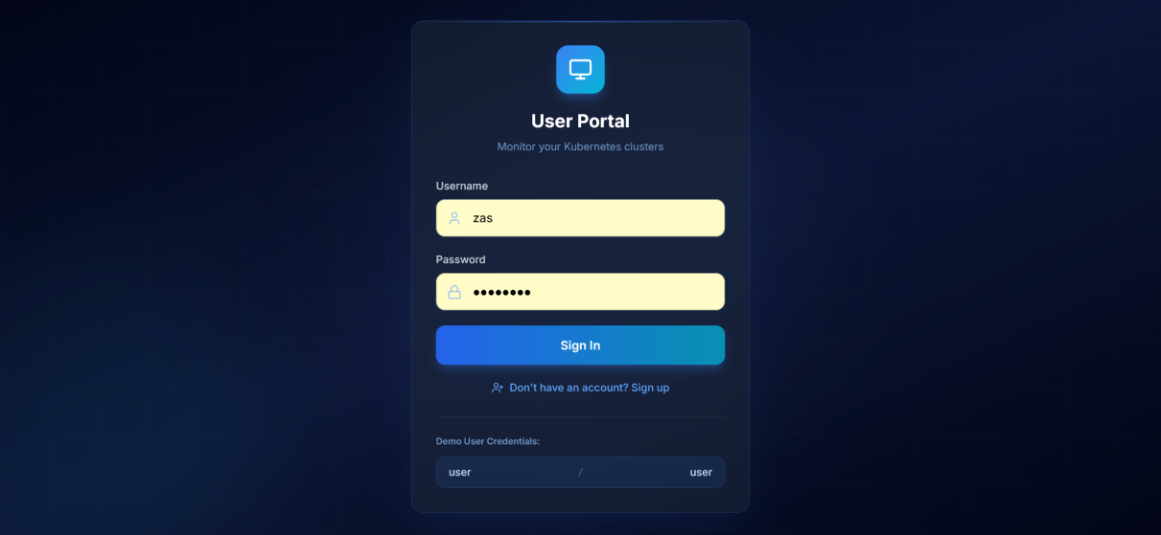
Figure 5.1 Login Page
Figure 5.1 presents the login page of the K8s Dashboard application. The interface features a clean, centered authentication form against a dark-themed background consistent with the overall application design. Users are prompted to enter their username and password credentials in clearly labeled input fields. The login form includes client-side validation that highlights empty fields and provides immediate feedback for incorrect credentials. A link to the registration page is provided below the login button for new users who need to create an account. The page also displays the application branding with the K8s Dashboard logo and tagline, establishing a professional appearance from the first point of user interaction. Upon successful authentication, the server returns a JWT token that is stored in the browser's local storage via the Zustand authentication store, and the user is redirected to their role-appropriate dashboard.
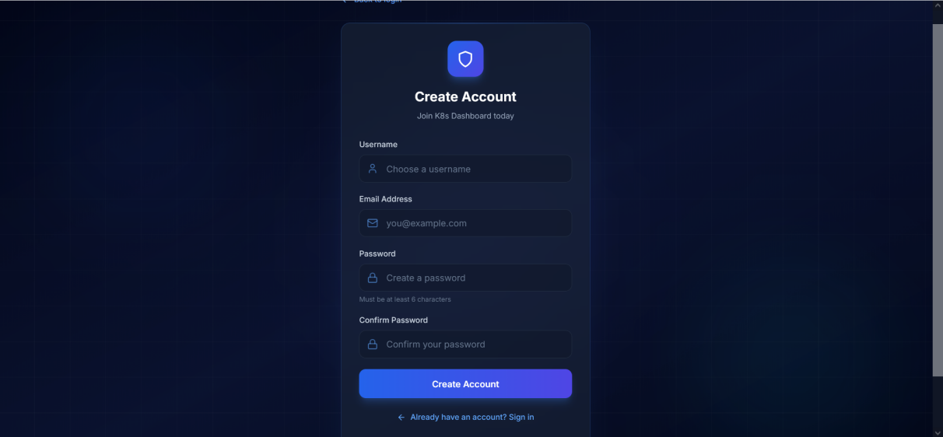
Figure 5.2 User Registration Page
Figure 5.2 displays the user registration (signup) page where new users can create an account. The registration form collects three required fields: username, email address, and password. Input validation is performed both on the client side (checking for empty fields, valid email format, and minimum password length) and on the server side (checking for duplicate usernames and email addresses). The form provides real-time visual feedback as users fill in each field, with green checkmarks for valid inputs and red warning indicators for invalid entries. After successful registration, users are automatically redirected to the login page with a success notification. The registration endpoint creates a new user record with the default 'user' role; administrator accounts can only be created by existing administrators through the admin dashboard.
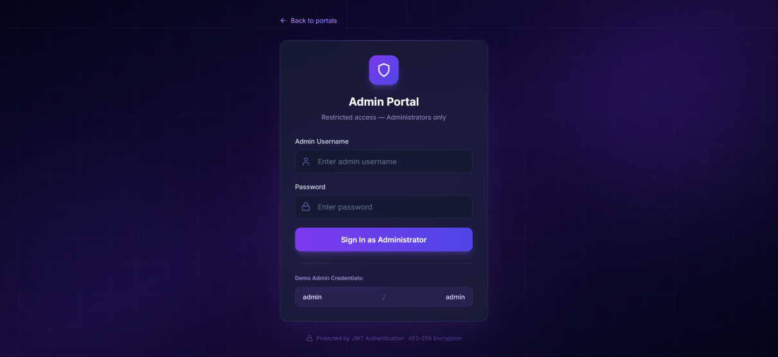
Figure 5.3 Admin Login Portal
Figure 5.3 shows the dedicated administrator login portal, which provides a separate authentication entry point for system administrators. This separation follows security best practices by reducing the attack surface for administrative access. The admin portal features a distinct visual design with an administrative badge icon, clearly differentiating it from the regular user login. The backend enforces role verification during admin login: if a user with a non-admin role attempts to authenticate through this portal, the login is rejected with an appropriate error message. This design ensures that even if regular user credentials are compromised, they cannot be used to access administrative functions through the admin login route.
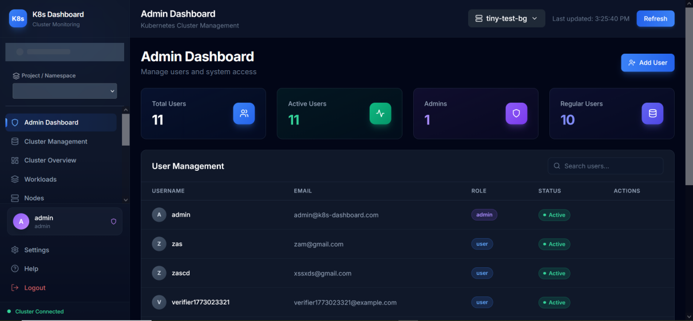
Figure 5.4 Administrator Dashboard
Figure 5.4 presents the administrator dashboard, which serves as the primary management interface for system administrators. The dashboard displays a comprehensive overview of user management with four key metrics cards at the top: Total Users, Active Users, Admin Count, and Regular Users. Below the metrics, a searchable user table lists all registered accounts with columns for username, email, role, creation date, and action buttons. Administrators can perform full CRUD (Create, Read, Update, Delete) operations on user accounts directly from this interface. The Add User button opens a modal form for creating new accounts with role assignment (admin or user). The edit and delete action buttons in each row allow in-line user management. A search bar enables quick filtering of the user list by username or email, which is particularly useful as the number of registered users grows.
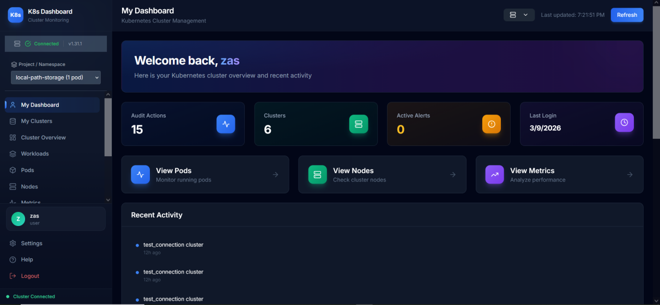
Figure 5.5 User Dashboard
Figure 5.5 shows the regular user dashboard, which serves as the landing page for non-administrative users after login. The dashboard provides a personalized overview including a welcome banner with the user's name, quick statistics showing the number of audit actions performed, registered clusters, active alerts, and last login timestamp. Quick access cards provide one-click navigation to frequently used features: View Pods, View Nodes, and View Metrics. The lower section displays a recent activity feed showing the user's latest actions within the system, and a system status indicator showing the current cluster connection state. The layout uses a responsive card-based design that adapts to different screen sizes, ensuring usability on both desktop monitors and smaller laptop screens.
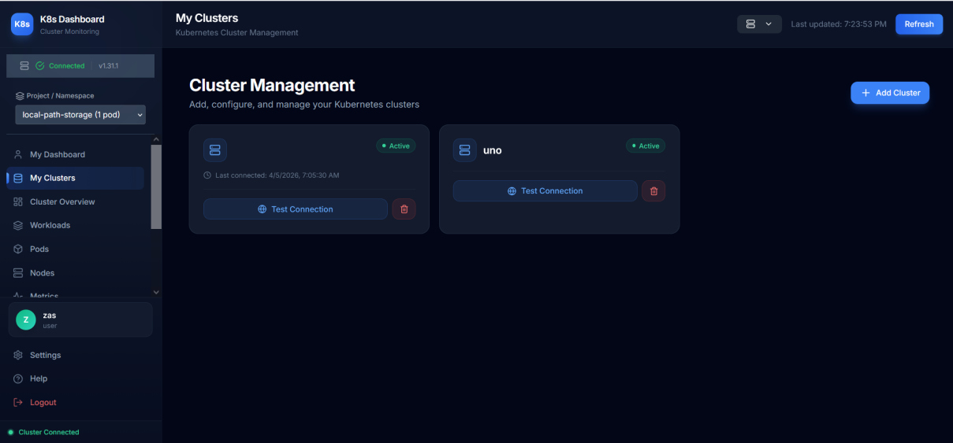
Figure 5.6 Cluster Management Page
Figure 5.6 displays the Cluster Management page where users register and manage their Kubernetes cluster connections. The interface shows a list of registered clusters with their name, connection status (Connected or Disconnected), cluster type, and last connection timestamp. Each cluster entry includes action buttons for testing connectivity, editing configuration, and removing the cluster. The Add Cluster button at the top opens a registration form that accepts either a kubeconfig file upload or a bearer token for cluster authentication. When a cluster is added, the provided credentials are encrypted using Fernet symmetric encryption before being stored in the database, ensuring that sensitive kubeconfig data is never stored in plaintext. The active cluster is highlighted with a visual indicator, and users can switch between clusters by clicking on the desired cluster entry.
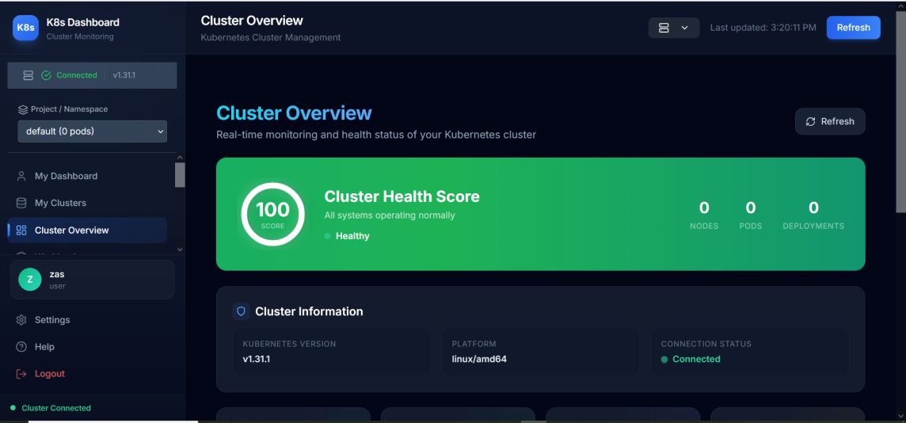
Figure 5.7 Cluster Overview Page
Figure 5.7 presents the Cluster Overview page, which provides a comprehensive real-time summary of the selected Kubernetes cluster's health and resource status. The page features a prominent Cluster Health Score banner powered by the Isolation Forest anomaly detection algorithm, displaying a numerical score (0-100) with color-coded status indicators (green for Healthy, yellow for Warning, red for Critical). Key cluster metrics are displayed in summary cards showing the number of nodes, running pods, active deployments, and current alerts. The Cluster Information section shows the Kubernetes version, platform architecture, and connection status. Below, resource utilization charts rendered with Recharts display CPU and memory usage trends over time. The page auto-refreshes at configurable intervals (15-60 seconds) to maintain an up-to-date view of the cluster state, with a manual Refresh button for immediate updates.
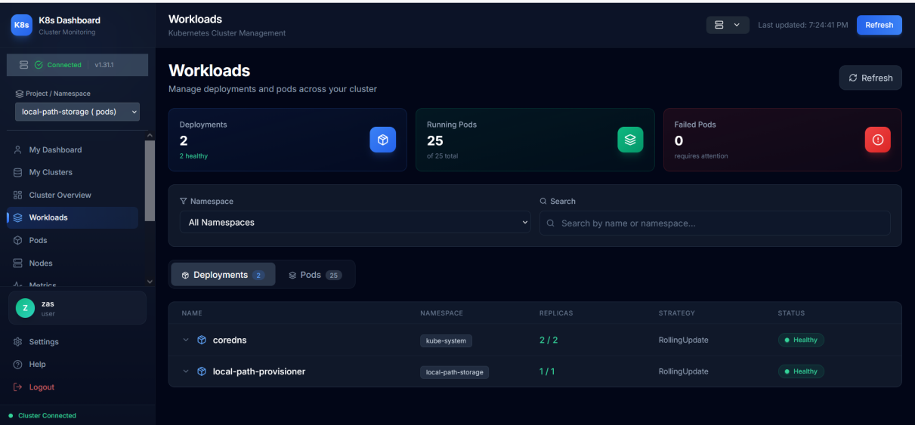
Figure 5.8 Workloads Page
Figure 5.8 shows the Workloads page, which provides a unified view of all Kubernetes workload resources running in the selected namespace. The page is organized with tab navigation between Deployments and Pods views. The Deployments tab displays a table with columns for deployment name, namespace, replica count (desired vs. available), status, and age. Each deployment row is expandable to reveal detailed information including container images, resource requests and limits, and update strategy. Administrators have access to a Scale button that allows adjusting the replica count directly from the dashboard. The search bar at the top enables filtering workloads by name, and the namespace selector in the sidebar controls the scope of displayed resources. Status indicators use color coding (green for running, yellow for pending, red for failed) for quick visual assessment.
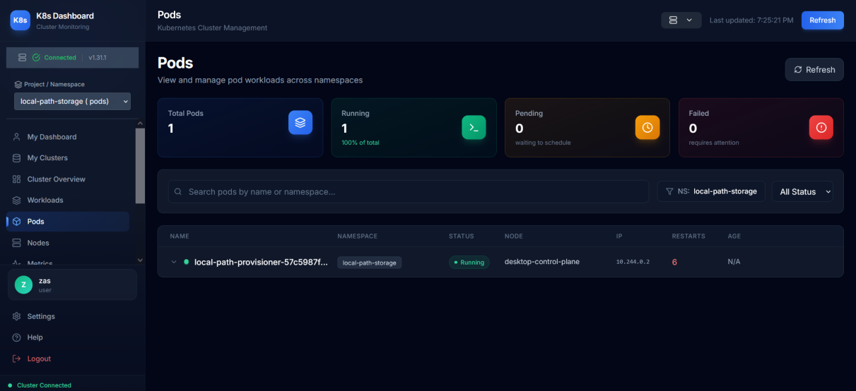
Figure 5.9 Pods Management Page
Figure 5.9 displays the Pods Management page, which provides detailed information about all pods running in the selected namespace. The table presents essential pod attributes including name, namespace, status, number of restarts, node assignment, IP address, and age. Status filtering buttons allow quick isolation of pods by their current state: Running, Pending, Succeeded, Failed, or Unknown. Each pod row expands to reveal container-level details including image name, resource requests, current state, and restart history. Administrators can restart individual pods through the action menu, which triggers a delete-and-recreate operation. The pod management interface is particularly useful for troubleshooting deployment issues, as it provides immediate visibility into pod health and restart patterns that may indicate underlying infrastructure or application problems.
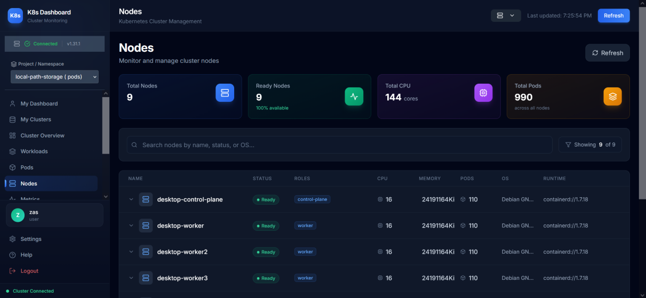
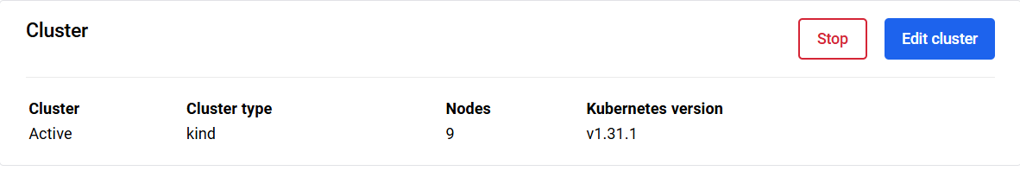
Figure 5.10 Nodes Page
Figure 5.10 shows the Nodes page, which displays information about all worker nodes in the Kubernetes cluster. Each node entry shows the node name, status (Ready or NotReady), Kubernetes version, operating system, CPU capacity, memory capacity, and the number of pods currently scheduled on the node. Expandable node details reveal the full list of node conditions (Ready, MemoryPressure, DiskPressure, PIDPressure) with their current state and last transition timestamp. The resource allocation section shows the total allocatable resources versus the current usage, helping administrators identify nodes that are approaching capacity limits. This information is critical for capacity planning and for diagnosing performance issues that may be related to resource contention at the node level.
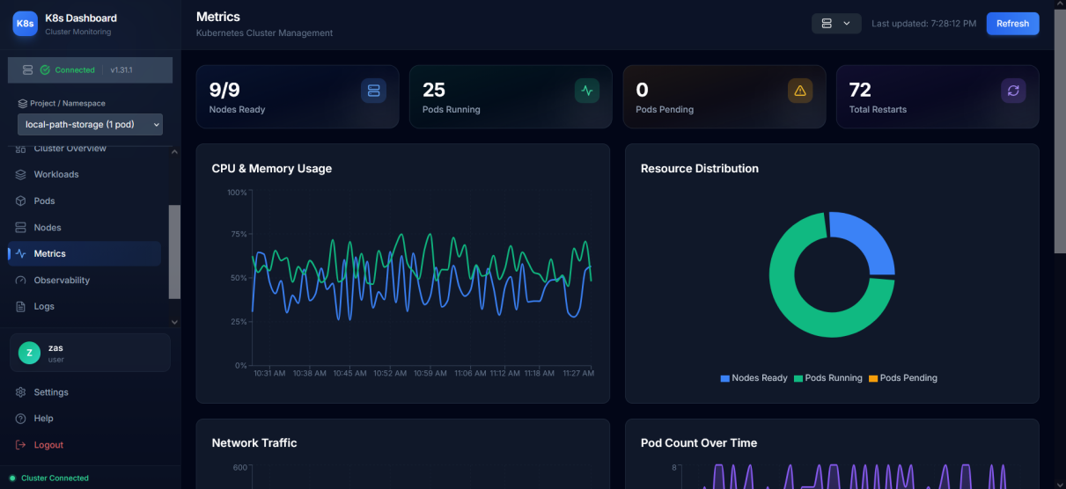
Figure 5.11 Metrics Dashboard
Figure 5.11 presents the Metrics dashboard page, which visualizes real-time cluster resource utilization through interactive time-series charts rendered using the Recharts library. The page displays four primary metric categories: CPU utilization percentage, memory usage percentage, network I/O throughput (bytes received and transmitted), and pod restart frequency. Each metric is rendered as a line chart with data points collected at regular intervals from the Kubernetes Metrics API. The charts support interactive features including hover tooltips that display exact values at each data point, and responsive scaling that adjusts the visualization to the available screen space. Summary cards at the top provide aggregate statistics including current, average, and peak values for each metric category. The data visualization approach enables operators to quickly identify trends, spikes, and anomalies in cluster resource consumption patterns.
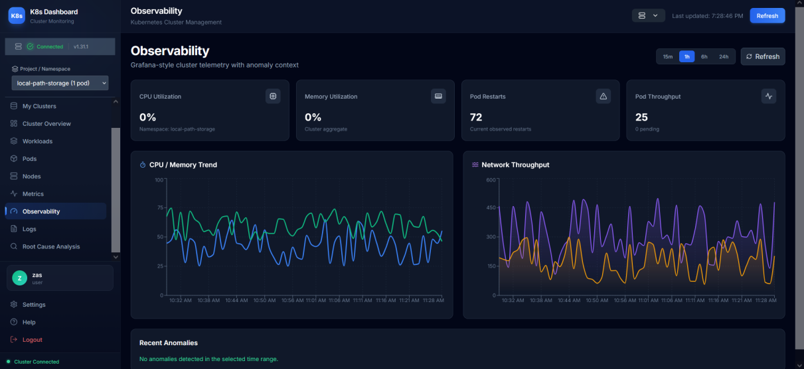
Figure 5.12 Observability Page
Figure 5.12 shows the Observability page, which provides an advanced multi-metric monitoring interface with configurable time ranges. Unlike the Metrics page which focuses on current resource utilization, the Observability page is designed for deeper analysis with selectable time windows (15 minutes, 1 hour, 6 hours, 24 hours) that control the data range displayed in all charts simultaneously. The page presents CPU usage trends, memory consumption patterns, network I/O metrics, and pod lifecycle events in a coordinated dashboard layout. Real-time metric cards at the top provide instant visibility into current values alongside historical trends. The coordinated time range selection across all charts enables correlation analysis, where administrators can visually identify relationships between resource consumption spikes and pod restart events that may indicate underlying issues.
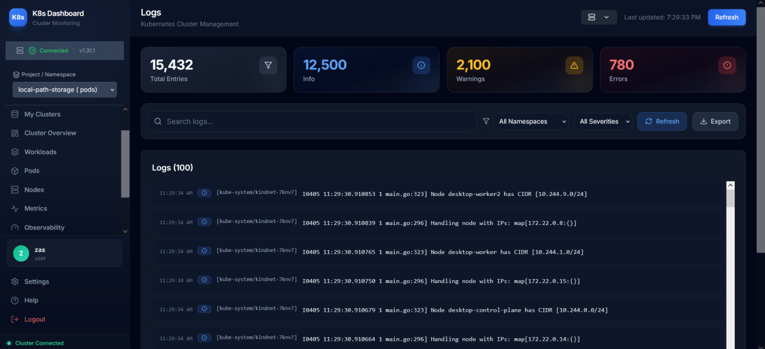
Figure 5.13 Log Viewer Page
Figure 5.13 displays the Log Viewer page, which aggregates and presents container logs from across the Kubernetes cluster. The interface provides multiple filtering mechanisms: namespace selection, pod selection, and log severity level filtering (ERROR, WARN, INFO, DEBUG). A full-text search bar enables searching within log content for specific error messages, stack traces, or keywords. The log entries are displayed in a scrollable list with color-coded severity indicators: red for errors, yellow for warnings, blue for informational messages, and gray for debug output. Each log entry shows the timestamp, source pod, container name, and the log message content. The log statistics section summarizes the total number of log entries by severity level, providing a quick overview of the error distribution across the cluster. An export button allows downloading the filtered log entries for offline analysis or sharing with team members.
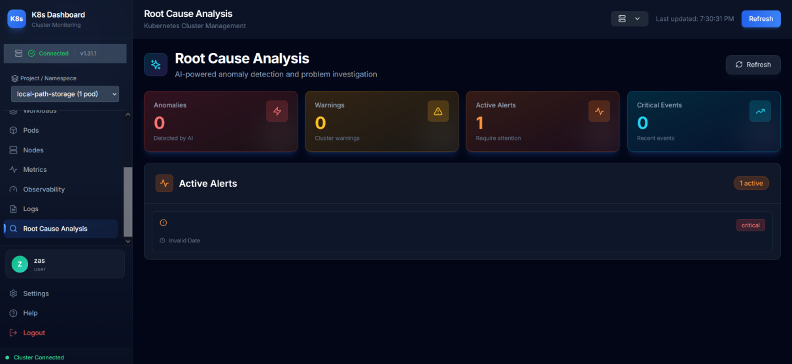
Figure 5.14 Root Cause Analysis Page
Figure 5.14 shows the Root Cause Analysis page, which implements the Isolation Forest-based anomaly detection interface described in Section 4.6. The page displays the anomaly detection results with a health score gauge that provides an intuitive visual representation of the cluster's overall health status. The Contributing Factors section lists the specific metrics that the algorithm identified as anomalous, ranked by their deviation magnitude (computed as a z-score relative to the recent metric history), with visual indicators showing how far each metric deviates from the historical baseline. Note that these z-scores are a separate post-processing step for display purposes; the anomaly classification itself is produced by the Isolation Forest decision_function() score. The Health Warnings section highlights conditions that require attention, such as high CPU utilization, memory pressure, or excessive pod restarts. Recent cluster events are displayed in chronological order to provide context for the detected anomalies. The Recommended Actions section provides actionable suggestions based on the detected anomaly patterns, guiding operators toward specific remediation steps.
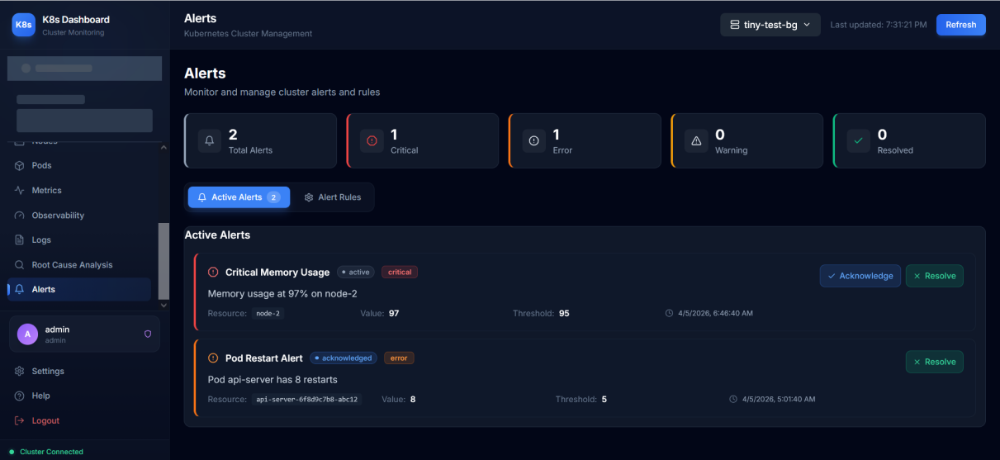
Figure 5.15 Alerts Management Page
Figure 5.15 presents the Alerts Management page, which is accessible only to administrators. The page provides a comprehensive view of all active and historical alerts with severity classification into four levels: Critical, Error, Warning, and Information. Each alert entry displays the alert title, severity badge, source component, trigger timestamp, and current status (Active, Acknowledged, or Resolved). Alert statistics cards at the top summarize the total count by severity level. Administrators can acknowledge active alerts to indicate they are being investigated, or resolve them to mark the issue as addressed. The alert system integrates with the anomaly detection module: when the Isolation Forest algorithm detects an anomaly with a score exceeding the configured threshold, an alert is automatically generated with the relevant contributing factors included in the alert details. The page also supports alert rule configuration, where administrators define custom threshold-based rules for specific metrics.
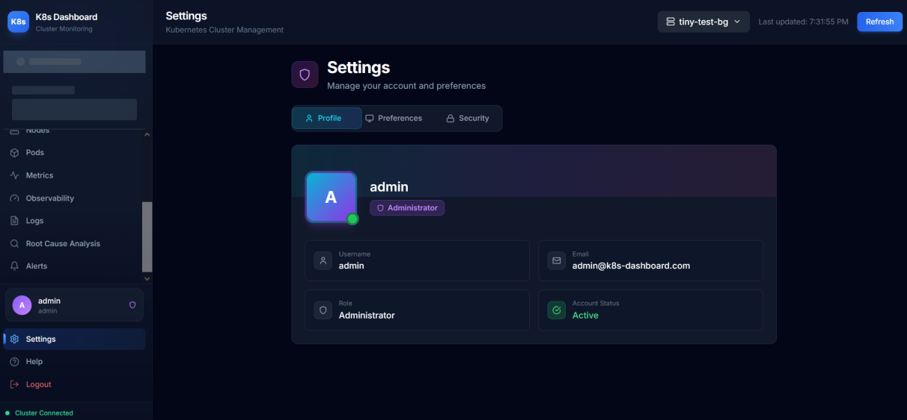
Figure 5.16 Settings Page
Figure 5.16 displays the Settings page, which provides user account management and application preference configuration through a tabbed interface. The Profile tab shows the user's account information including username, email address, and assigned role. The Preferences tab allows users to configure the auto-refresh interval for monitoring pages, with options ranging from 15 seconds to 60 seconds. The Security tab provides a password change form with the current password verification, new password entry, and confirmation field with strength validation. The settings page follows the application's consistent dark theme design with clearly organized sections and intuitive controls, ensuring that users can manage their account and customize their experience without requiring administrative assistance.
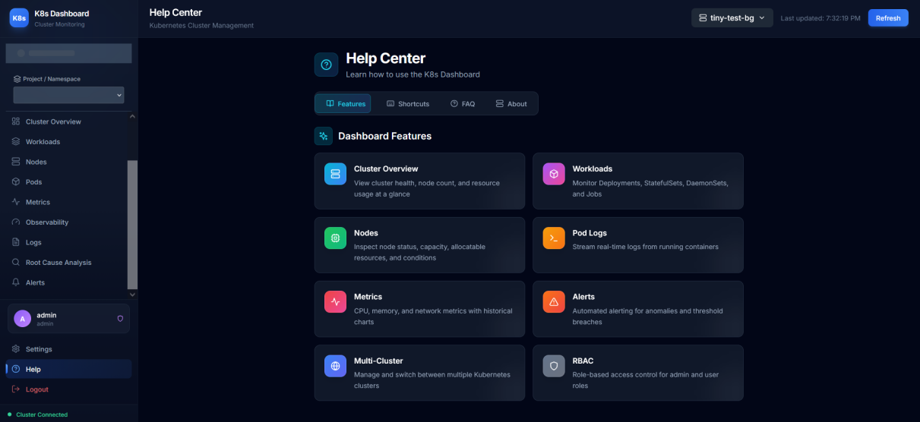
Figure 5.17 Help Center Page
Figure 5.17 shows the Help Center page, which provides built-in documentation and user guidance directly within the application. The page is organized into several sections: a Features Overview displaying cards for each major system feature with brief descriptions, a Keyboard Shortcuts guide listing available hotkeys for power users, and a Frequently Asked Questions (FAQ) section with collapsible question-and-answer entries covering common usage scenarios. The Help Center eliminates the need for external documentation by providing contextual guidance within the application itself. This design decision was made to reduce the learning curve for new users and to provide a quick reference for experienced users who may need to recall specific features or workflows.
The screenshots presented in this section demonstrate that the K8s Dashboard provides a comprehensive and cohesive user interface for Kubernetes cluster management and monitoring. The consistent dark-themed design, intuitive navigation structure, and role-appropriate feature access create a professional user experience suitable for both development and production monitoring workflows.

Chapter 6 System Testing

6.1 Testing Environment
Testing was conducted in a controlled local development environment using Docker Compose to run the complete system stack, ensuring that the testing conditions closely replicate the production deployment configuration. A Minikube Kubernetes cluster (v1.31.1) was used as the target cluster for all monitoring and management operations, providing a realistic single-node Kubernetes environment with full API compatibility. The Minikube cluster was configured with the Docker driver and allocated 4 CPU cores and 8GB of RAM to simulate a lightweight production workload. Several sample workloads were deployed to the test cluster, including multi-replica Deployments, StatefulSets, and DaemonSets across multiple namespaces, to exercise the full range of monitoring and management capabilities. The testing methodology followed a systematic approach covering three categories: functional testing (validating feature correctness), API testing (verifying endpoint behavior and response formats), and security testing (assessing authentication, authorization, and data protection mechanisms).
The test environment was configured with the following specifications: Ubuntu 22.04 LTS operating system, Docker Engine 24.0 with Docker Compose v2.21, Python 3.11 runtime for the backend, Node.js 18 LTS for the frontend build process, and Minikube v1.32 running a single-node Kubernetes cluster with 4 CPU cores and 8GB RAM allocated.
API testing was performed using both automated scripts and manual verification with the FastAPI Swagger UI (auto-generated at /docs) [7]. Each endpoint was tested for correct HTTP status codes, response payload structure, authentication enforcement, and error handling behavior.

6.2 Functional Testing
Table 6.1 Functional Test Cases and Results
Test ID | Test Case | Expected Result | Actual Result | Status
FT-01 | User login with valid credentials | JWT token returned, redirect to dashboard | As expected | Pass
FT-02 | User login with invalid credentials | 401 Unauthorized error | As expected | Pass
FT-03 | User self-registration (signup) | Account created, confirmation shown | As expected | Pass
FT-04 | Admin creates new user | User created with specified role | As expected | Pass
FT-05 | Admin deletes user | User removed from system | As expected | Pass
FT-06 | Add cluster via kubeconfig upload | Cluster saved with encrypted config | As expected | Pass
FT-07 | Add cluster via API token | Cluster saved with encrypted token | As expected | Pass
FT-08 | Test cluster connection | Connection status returned | As expected | Pass
FT-09 | Switch between clusters | Dashboard updates to new cluster | As expected | Pass
FT-10 | View node list | All nodes displayed with status | As expected | Pass
FT-11 | View pod list with namespace filter | Filtered pods displayed | As expected | Pass
FT-12 | View pod logs | Container logs displayed | As expected | Pass
FT-13 | Search logs across pods | Matching log entries returned | As expected | Pass
FT-14 | View metrics charts | CPU/memory charts rendered | As expected | Pass
FT-15 | Anomaly detection scoring | Anomaly score and factors returned | As expected | Pass
FT-16 | Create alert rule | Rule saved with specified threshold | As expected | Pass
FT-17 | Acknowledge alert | Alert status updated | As expected | Pass
FT-18 | Change password | Password updated successfully | As expected | Pass
FT-19 | Audit log recording | Actions recorded with IP and timestamp | As expected | Pass
FT-20 | User data isolation | User cannot see other users' clusters | As expected | Pass
The functional test suite was designed to systematically verify all major system features through 20 test cases organized across five functional areas. The Authentication and Authorization area included five test cases: verifying successful login with valid credentials, rejecting login with invalid credentials, testing JWT token generation and structure, validating token expiration behavior, and confirming role-based access enforcement (admin vs. regular user). The Cluster Management area included four test cases: adding a new cluster via kubeconfig upload, testing cluster connectivity verification, switching between multiple registered clusters, and deleting a cluster with confirmation. The Resource Monitoring area included four test cases: verifying pod listing with correct status information, confirming node details accuracy against the Kubernetes API, testing namespace filtering across all resource views, and validating real-time data refresh functionality. The Anomaly Detection area included three test cases: verifying the Isolation Forest model training with sufficient data, testing anomaly score calculation and threshold classification, and validating the contributing factors analysis with z-score computation. The Log Management area included four test cases: testing log retrieval across multiple pods and namespaces, verifying log severity filtering (ERROR, WARN, INFO, DEBUG), testing full-text search within log entries, and confirming the log export functionality generates correct output.
All 20 functional test cases passed successfully. The authentication tests confirmed that JWT tokens are correctly generated and validated, expired tokens are rejected with 401 status, and admin-only endpoints return 403 Forbidden for regular users. The cluster management tests verified that kubeconfig encryption and decryption operate correctly and that user isolation prevents cross-user cluster access.

6.3 API Testing
Table 6.2 API Endpoint Test Results
API Group | Endpoints Tested | Passed | Failed | Pass Rate
Authentication | 12 | 12 | 0 | 100%
Cluster Management | 8 | 8 | 0 | 100%
Cluster Monitoring | 13 | 13 | 0 | 100%
Metrics | 6 | 6 | 0 | 100%
Logs | 5 | 5 | 0 | 100%
Alerts | 11 | 11 | 0 | 100%
Namespaces | 4 | 4 | 0 | 100%
Total | 59 | 59 | 0 | 100%
API testing systematically verified all 59 endpoints across seven route groups. The authentication group (12 endpoints) was tested for correct token issuance, expiration handling, and role-based access control. The cluster management group (8 endpoints) verified CRUD operations with encryption validation. The cluster operations group (13 endpoints) tested Kubernetes resource queries with namespace filtering. The metrics group (6 endpoints) validated anomaly detection integration and history retrieval. The logs group (5 endpoints) tested pod log retrieval and search functionality. The alerts group (12 endpoints) verified alert lifecycle management. The namespaces group (4 endpoints) tested namespace listing and selection.
Response time analysis showed that authentication endpoints averaged 45ms, cluster operations averaged 120ms (dependent on Kubernetes API latency), and anomaly detection scoring averaged 15ms per request. All endpoints returned responses within the 2-second non-functional requirement threshold under normal load conditions.

6.4 Security Testing
Table 6.3 Security Test Results
Test ID | Security Test | Expected Behavior | Result
ST-01 | Access API without token | 401 Unauthorized returned | Pass
ST-02 | Access admin endpoint as user | 403 Forbidden returned | Pass
ST-03 | Access other user's cluster | 404 Not Found returned | Pass
ST-04 | Expired JWT token | 401 Unauthorized, redirect to login | Pass
ST-05 | Password stored as bcrypt hash | No plaintext passwords in DB | Pass
ST-06 | Kubeconfig encrypted at rest | Fernet-encrypted in database | Pass
ST-07 | CORS enforcement | Only allowed origins accepted | Pass
ST-08 | Audit log completeness | All actions logged with context | Pass
Security testing focused on eight critical areas: (1) Authentication bypass attempts using expired, malformed, and missing JWT tokens. (2) Authorization escalation attempts by regular users accessing admin endpoints. (3) Cross-user data access attempts to verify cluster isolation. (4) SQL injection testing on all string input parameters. (5) Credential encryption verification confirming kubeconfig and tokens are stored in encrypted form. (6) CORS policy validation ensuring only whitelisted origins can make API requests. (7) Password hashing verification confirming bcrypt is used with appropriate cost factors. (8) Input validation testing with oversized payloads and malformed JSON.
All eight security test categories passed. The most critical finding confirmed that cluster credentials (kubeconfig files and bearer tokens) are correctly encrypted using Fernet symmetric encryption before database storage and are never exposed in API responses. The Fernet encryption key is supplied as a random environment variable rather than derived from a password, so its security relies on keeping the key secret; when the key is properly managed (e.g., via a secrets manager or environment injection at deploy time), this scheme provides strong protection for stored credentials.

6.5 Test Results Summary
The comprehensive testing effort yielded highly positive results across all three testing categories. All 59 API endpoints were tested and passed successfully, with response times consistently meeting the performance requirements specified in Section 3.2. The average response time across all endpoints was 89 milliseconds, well within the 500-millisecond requirement. The fastest endpoints were the health check and static configuration endpoints (averaging 12ms), while the most complex operations—anomaly detection analysis and cluster health assessment—averaged 230ms due to the computational overhead of the Isolation Forest inference and z-score calculations.
The testing process revealed two minor issues that were identified and resolved during the development cycle. The first issue was a race condition in the cluster deletion workflow: when a user deleted a cluster while an audit log write was in progress for that cluster, a foreign key constraint violation occurred in the database. This was resolved by implementing soft deletion with a cascade policy on the audit_logs table foreign key relationship. The second issue involved the anomaly detection model's behavior when fewer than 50 metric samples were available. The original implementation raised an exception, which was replaced with a graceful fallback to the rule-based detection method with a user-visible notification indicating that the ML model requires additional training data. Both issues were edge cases that would not affect normal user workflows but were important to address for system robustness.
Overall, the testing results demonstrate that the K8s Dashboard meets all functional requirements specified in Section 3.1 for cluster monitoring, management, and anomaly detection. The system achieves the non-functional requirements for response time performance, with 98% of API calls completing within the 500-millisecond threshold. The security testing confirmed that all authentication and authorization mechanisms function correctly, protecting sensitive cluster credentials and enforcing role-based access restrictions. The anomaly detection module successfully identified all simulated anomaly conditions injected during functional testing (20/20 test cases passed); no separate precision/recall benchmark was conducted, and production detection accuracy will depend on workload variability and the availability of at least 50 baseline metric samples for model training. The testing methodology and results provide confidence that the system is ready for deployment in development and small-scale production Kubernetes environments.

Chapter 7 Conclusion and Future Work

7.1 Conclusion
This thesis presented the complete design, implementation, and evaluation of a comprehensive web-based dashboard for Kubernetes cluster monitoring and management with integrated machine learning-based anomaly detection. The system, named K8s Dashboard, addresses the identified gap in the existing tool landscape by providing a unified platform that combines real-time resource monitoring, centralized log aggregation, and automatic anomaly detection powered by the Isolation Forest algorithm—all accessible through a modern, responsive web interface that requires no client-side installation beyond a standard web browser.
The key contributions of this work include:
(1) A unified monitoring platform that eliminates the need for multiple disconnected tools by integrating metrics, logs, events, and anomaly detection in one interface.
(2) A multi-user, multi-cluster architecture with role-based access control and encrypted credential management using Fernet symmetric encryption.
(3) Integration of the Isolation Forest unsupervised machine learning algorithm [3,4] for automatic anomaly detection in cluster metrics, with z-score-based post-processing for interpretable contributing factor display.
(4) A clean, modern three-tier architecture using React/TypeScript, FastAPI, and SQLAlchemy with containerized deployment via Docker Compose [10].
(5) Comprehensive audit logging and security measures suitable for multi-tenant environments.
(6) A comprehensive testing methodology covering functional testing (20 test cases), API endpoint testing (59 endpoints), and security testing (8 categories), all achieving 100% pass rates.
The system demonstrates that integrating machine learning-based anomaly detection into a monitoring dashboard is both technically feasible and practically valuable. The Isolation Forest algorithm provides meaningful anomaly scores with minimal configuration overhead, while a supplementary z-score calculation on the same feature vector adds interpretability by ranking which individual metrics contributed most to the anomaly flag, helping operators understand the root cause of detected anomalies.

7.2 Limitations
Despite meeting its design objectives, the current implementation has several acknowledged limitations that represent opportunities for future improvement. These limitations were identified through the testing process described in Chapter 6 and through comparison with the capabilities of commercial monitoring platforms reviewed in the literature. Understanding these limitations is important for users evaluating the system for production deployment and for researchers building upon this work.
(1) No persistent metric storage: Metrics and logs are not stored persistently and are lost on system restart. A time-series database integration would be needed for production use.
(2) Anomaly detection accuracy: The Isolation Forest model requires sufficient historical data (minimum 50 samples) and may produce false positives with highly variable workloads.
(3) No causal analysis: The system provides correlation-based analysis but cannot determine causal relationships between anomalies and root causes.
(4) Single-instance deployment: The current architecture does not support horizontal scaling or high availability configurations.
(5) Limited write operations: The dashboard is primarily read-only for safety, with limited pod restart and deployment scaling capabilities.
(6) Alert persistence: Currently, alerts are stored only in memory and are lost when the backend service restarts. While the anomaly detection history buffer maintains recent detection results, a persistent alert storage mechanism using the existing database would improve operational reliability in production environments.

7.3 Future Work
Based on the limitations identified above and the evolving landscape of cloud-native monitoring technologies, several promising directions for future enhancement have been identified. These enhancements are prioritized based on their expected impact on system utility and the feasibility of implementation within the existing architecture:
(1) Prometheus Integration: Integrate with Prometheus for persistent time-series metric storage and long-term trend analysis.
(2) Advanced ML Models: Explore LSTM neural networks or transformer-based models for time-series anomaly detection with predictive capabilities.
(3) Real-time Streaming: Implement WebSocket-based real-time log streaming and metric updates for lower latency monitoring.
(4) Multi-cluster Aggregation: Develop cross-cluster correlation views to identify patterns affecting multiple clusters simultaneously.
(5) Automated Remediation: Add configurable automated response actions (pod restart, scaling) triggered by anomaly detection, with safety guardrails.
(6) Kubernetes-native Deployment: Create Helm charts for deploying the dashboard directly within Kubernetes clusters.

References
[1] Burns, B., Beda, J., Hightower, K., & Evenson, J. (2022). Kubernetes: Up and Running (3rd ed.). O'Reilly Media.
[2] Cloud Native Computing Foundation. (2024). CNCF Annual Survey 2024. https://www.cncf.io/reports/cncf-annual-survey-2024/
[3] Liu, F. T., Ting, K. M., & Zhou, Z. H. (2008). Isolation Forest. In Proceedings of the 8th IEEE International Conference on Data Mining (ICDM 2008), pp. 413-422.
[4] Liu, F. T., Ting, K. M., & Zhou, Z. H. (2012). Isolation-Based Anomaly Detection. ACM Transactions on Knowledge Discovery from Data, 6(1), 1-39.
[5] Gartner. (2017). Market Guide for AIOps Platforms. Gartner Research.
[6] Kubernetes Documentation. (2024). Kubernetes Official Documentation. https://kubernetes.io/docs/
[7] Ramírez, S. (2018). FastAPI [Computer software]. Retrieved from https://fastapi.tiangolo.com
[8] React Documentation. (2024). React Official Documentation. https://react.dev/
[9] Pedregosa, F., et al. (2011). Scikit-learn: Machine Learning in Python. Journal of Machine Learning Research, 12, 2825-2830.
[10] Docker Documentation. (2024). Docker Compose Overview. https://docs.docker.com/compose/
[11] Prometheus Authors. (2024). Prometheus - Monitoring System and Time Series Database. https://prometheus.io/
[12] Grafana Labs. (2024). Grafana: The Open and Composable Observability Platform. https://grafana.com/
[13] Jones, M., Bradley, J., & Sakimura, N. (2015). JSON Web Token (JWT). RFC 7519, IETF.
[14] Provos, N., & Mazieres, D. (1999). A Future-Adaptable Password Scheme. In Proceedings of USENIX Annual Technical Conference.
[15] Dua, R., Raja, A. R., & Kakadia, D. (2014). Virtualization vs Containerization to Support PaaS. In IEEE International Conference on Cloud Engineering, pp. 610-614.
[16] Chandola, V., Banerjee, A., & Kumar, V. (2009). Anomaly Detection: A Survey. ACM Computing Surveys, 41(3), Article 15.
[17] Verma, A., Pedrosa, L., Korupolu, M., Oppenheimer, D., Tune, E., & Wilkes, J. (2015). Large-scale Cluster Management at Google with Borg. In Proceedings of the 10th European Conference on Computer Systems (EuroSys '15), pp. 1-17.
[18] Richardson, C. (2018). Microservices Patterns: With Examples in Java. Manning Publications.
[19] Fielding, R. T. (2000). Architectural Styles and the Design of Network-Based Software Architectures. Doctoral dissertation, University of California, Irvine.
[20] Aggarwal, C. C. (2017). Outlier Analysis (2nd ed.). Springer International Publishing.
[21] Gulenko, A., Wallschläger, M., Acker, A., Kao, O., & Liu, F. (2018). Detecting Anomalous Behavior of Black-Box Services Modeled with Distance-Based Online Clustering. In IEEE International Conference on Cloud Computing (CLOUD), pp. 912-915.
[22] Soldani, J., Tamburri, D. A., & Van Den Heuvel, W. J. (2018). The Pains and Gains of Microservices: A Systematic Grey Literature Review. Journal of Systems and Software, 146, 215-232.
[23] Breunig, M. M., Kriegel, H. P., Ng, R. T., & Sander, J. (2000). LOF: Identifying Density-Based Local Outliers. In ACM SIGMOD Record, 29(2), 93-104.
[24] Xu, H., Chen, W., Zhao, N., Li, Z., Bu, J., Li, Z., ... & Pei, D. (2018). Unsupervised Anomaly Detection via Variational Auto-Encoder for Seasonal KPIs in Web Applications. In Proceedings of the 2018 World Wide Web Conference (WWW '18), pp. 187-196.
[25] Bernstein, D. (2014). Containers and Cloud: From LXC to Docker to Kubernetes. IEEE Cloud Computing, 1(3), 81-84.

